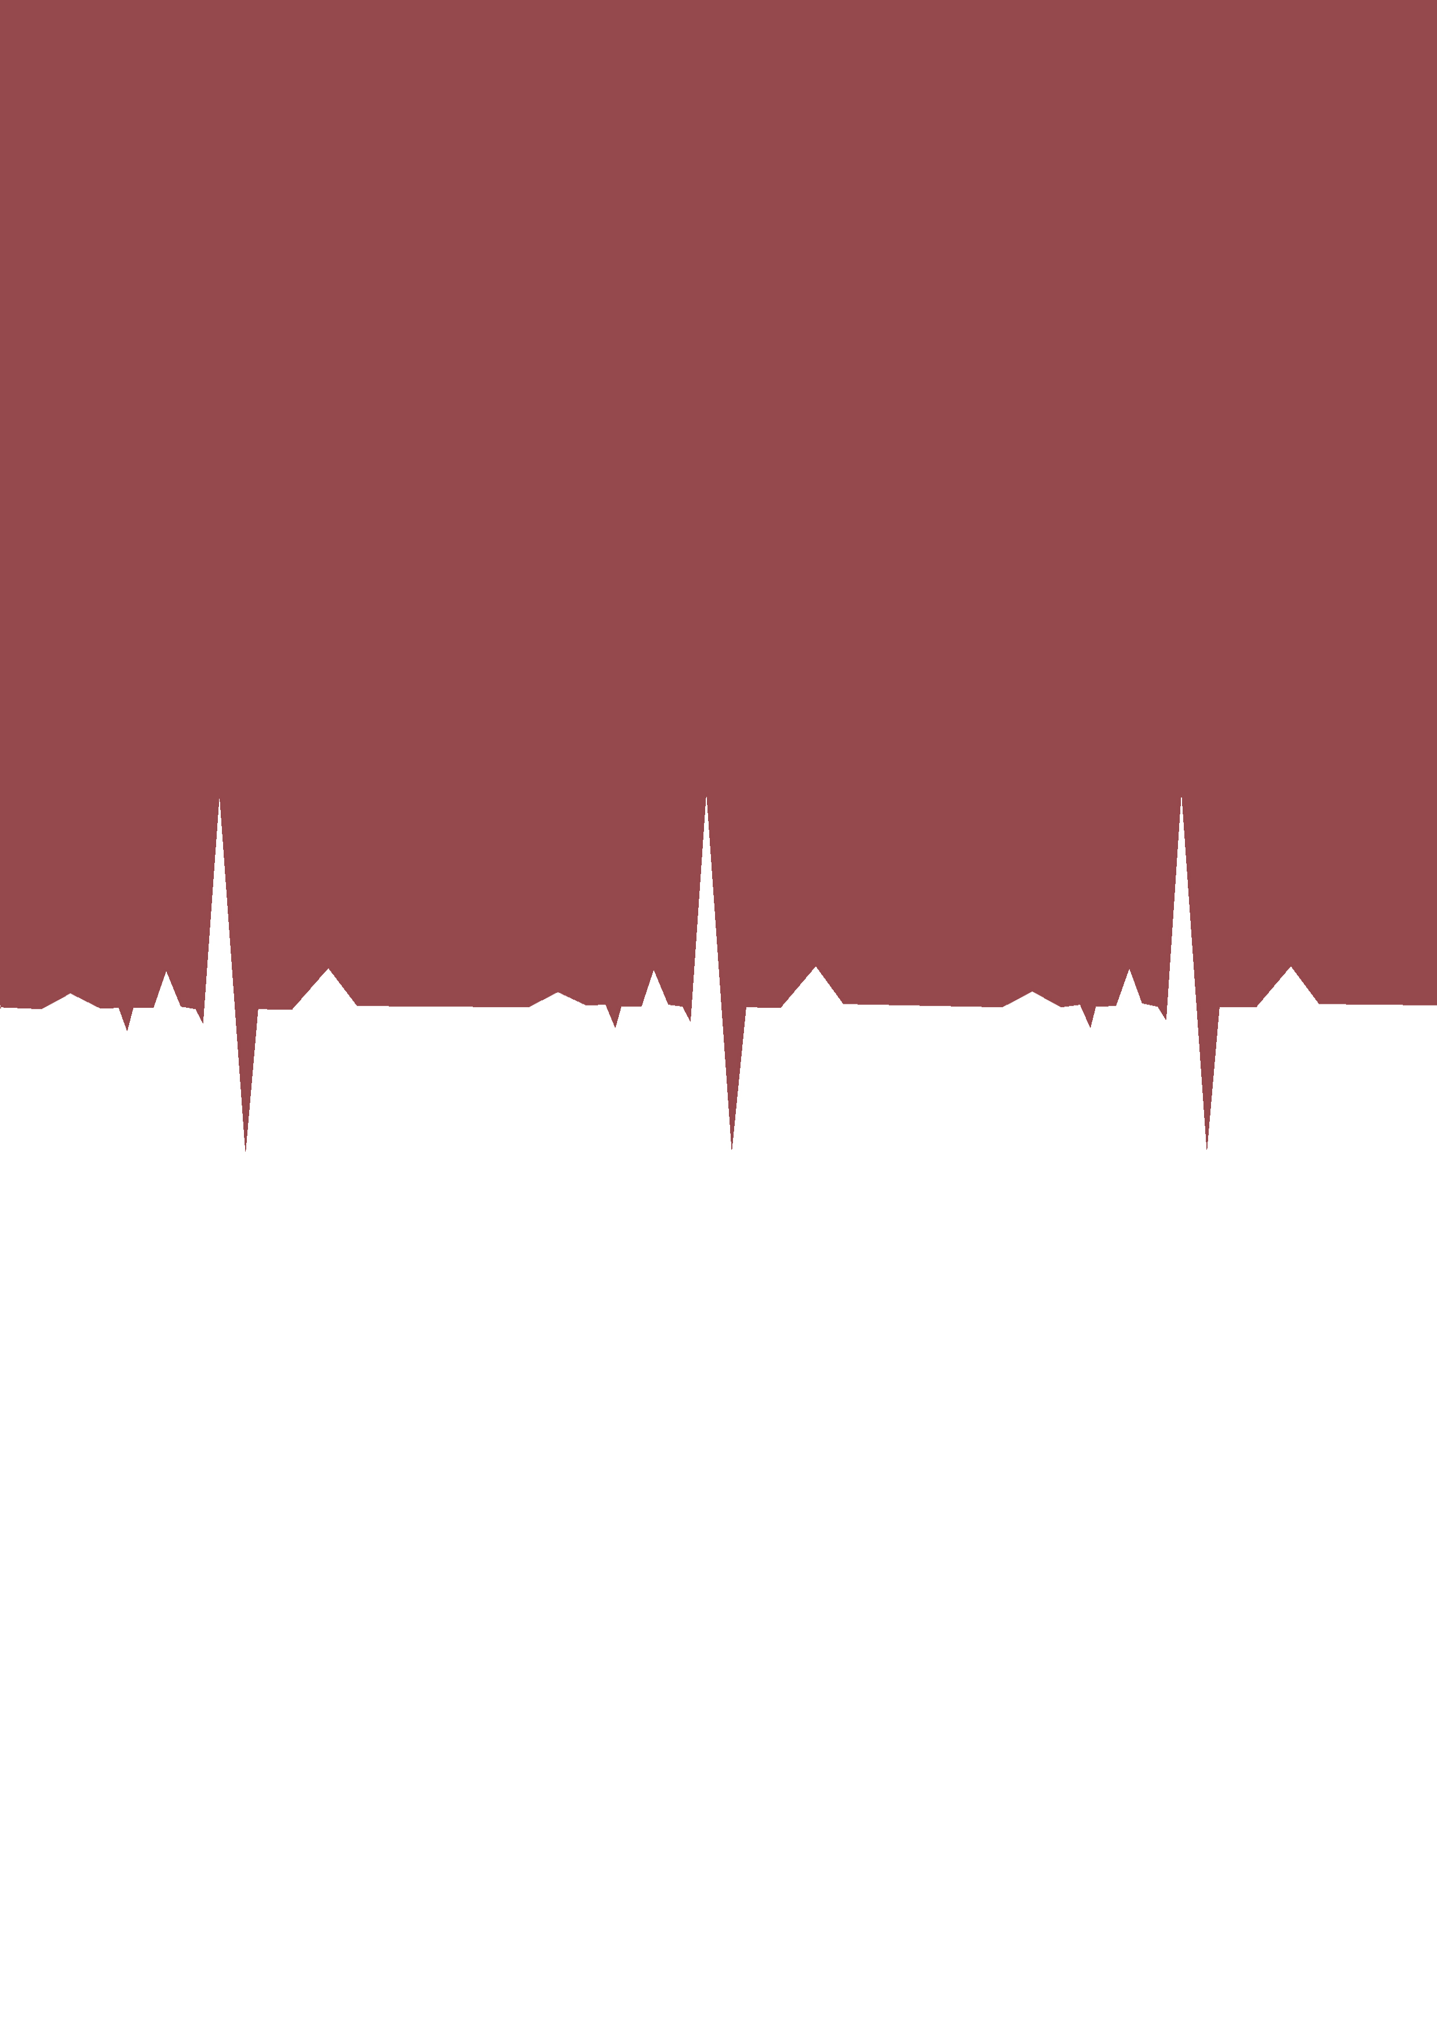**Community Clinic Management System (CCMS)**

[ECG Data Processing, Analysis, Heart Condition Prediction, Solution]

A Project Report

Submitted to the department of Computer Science and Engineering

In partial fulfillment of the requirements for the

Bachelor of Science in Computer Science and Engineering (CSE)

**Submitted By**

|  |  |
| --- | --- |
| Md. Golam Habib | ID#160221001 |
| Md. Ashikur Rahman | ID# 160221005 |
| Md. Nazrul Islam | ID# 160221006 |
| Md. Elias Hossain | ID# 160221007 |
| Aktarul Islam | ID# 160221008 |
| Habiba Arfin | ID# 160221009 |

**Supervised** **By**

**Md. Obaidur Rahman**

Associate Professor and Chairman

Department of Computer Science and Engineering

European University of Bangladesh (EUB),

Gabtoli, Dhaka 1216

# Letter of Transmittal

27 August 2020

To,

Md. Obaidur Rahman,

Associate Professor and Chairman

Department of Computer Science & Engineering,

European University of Bangladesh,

2/4 Gabtoli, Mirpur,Dhaka – 1216.

Subject: Submission of Project Report on “**Community Clinic Management System**”.

Dear Sir,

It is our great pleasure to submit the project on “**Community Clinic Management System”** which has been assigned as a mandatory requirement for the completion of the BSC program. We have tried our best to give this report a presentable shape and make appropriate and informative to accomplish the objectives of the study.

We would like to convey our gratitude to you for giving me the opportunity to work on such a topic which is very much relevant to our study. We sincerely believe that the practical knowledge and experience gathered from the study will be very much helpful in our future life for doing this type of project report.

Sincerely,

|  |  |
| --- | --- |
| Md. Golam Habib | ID#160221001 |
| Md. Ashikur Rahman | ID# 160221005 |
| Md. Nazrul Islam | ID# 160221006 |
| Md. Elias Hossain | ID# 160221007 |
| Aktarul Islam | ID# 160221008 |
| Habiba Arfin | ID# 160221009 |

Department of Computer Science & Engineering,

European University of Bangladesh.

# Declaration of Student’s

Declaration of Student's we are, hereby declared that the presented report of Project named "**Community Clinic Management System**" is prepared by us.

We also confirm that the report is only prepared to meet my academic requirement not for any other purpose. This Project work has not been previously submitted for any degree at this university. I have quoted from the work of others; the source is always given. With the exception of such quotations, this project is entire my own work.

Habiba Arfin

ID# 160221009

Aktarul Islam

ID# 160221008

Md. Elias Hossain

ID# 160221007

Md. Nazrul Islam

ID# 160221006

Md. Ashikur Rahman

ID# 160221005

Md. Golam Habib

ID# 160221001

Batch – 4th (Regular)

Department of Computer Science & Engineering,

European University of Bangladesh.

# Declaration of Supervisor's



**EUROPEAN UNIVERSITY OF BANGLADESH**



**To Whom It May Concern**

This is to certify that the project report on " **Community Clinic Management System** "For the degree Bachelor of Science in Computer Science and Engineering from European University of Bangladesh carried out by Md. Golam Habib Student ID# 160221001, Md. Ashikur Rahman Student ID# 160221005, Nazrul Islam Student ID# 160221006, Md. Elias HossainStudent ID# 160221007, Aktarul Islam ID#160221008, Habiba Arfin ID#160221009 under our supervision.

As far as we are concern, no part of the project report has been submitted for any degree diploma, title or recognition before.

……………………………

**Md. Obaidur Rahman**Associate Professor and Chairman  
Department of Computer Science and Engineering  
European University of Bangladesh (EUB)



# Acknowledgement

At the very beginning, we would like to convey our sincere appreciation to the Almighty Allah for giving us the strength and ability to complete the task within the specified time.

Any project report is the product of numerous people whose efforts, ideas and suggestions make the writer's job manageable. We are indebted to many people and organization for their assistance in making this project report a reality.

We are very much thankful to our honorable supervisor, Md. Obaidur Rahman, Associate Professor and Chairman, Department of Computer Science and Engineering, for his kind perseverance and contributions. Without his constant supervision and valuable advices and suggestions, we would not be able to complete the whole thing in a right manner.

As always, any errors or omissions are the sole responsibilities of the writers. Any suggestions improving the quality of this project report are welcome.

# Executive Summery

In Bangladesh, since 2009, establishment of 14 000 community clinics (CCs) for every 6000 population across the country brings health care to the community doorstep ([WHO](http://origin.searo.who.int/mediacentre/events/community-clinic-bangladesh-story.pdf)). Now people can avail of health, family planning and nutrition services under one roof and within half-an-hour walking distance from their homes, even in remote areas.

CCs have contributed significantly to the improvement of the overall antenatal and postnatal care in Bangladesh. The clinics provide counseling on reproductive health and consequences of early marriage, and also supply contraceptives as well as care for pregnant women. Treatment is also provided for diarrhea, pneumonia and other childhood infections.

People’s participation is an important element of CCs. Local community members actively participate in their management.

The Health and Population Sector Programme (1998-2003) aimed to bring important changes to health and family planning services in Bangladesh. The introduction of a sector wide approach brought a series of changes in the planning, financing and delivery of services. A key component was the development of the new Essential Services Package (ESP) to meet the needs of the poor, especially in rural areas and particularly women and children. Village level facilities were to be developed as a focus for the provision of ESP. These Community Clinics were to bring family planning, preventive health services and limited curative services closer to the population, and to improve the efficiency of service provision, partly by replacing outreach services with services provided from a fixed point. Community Clinics (CC) were to provide services for around 6000 people, and it was envisaged that their location would make them accessible for 80% of the population within less than 30 minutes walking distance. The design was to be simple – two rooms with drinking water and lavatory facilities, and a covered waiting area. Funds for building the clinics were provided centrally, but communities had to donate land. This was designed to increase the feeling of ownership of the developments. In a similar way each community was required to set up a group to support and assist with the management of the CC, although the staff and supplies were provided by the government. Each clinic should have two staff, one health assistant and one family welfare assistant. There is a specified allocation of equipment and a range of drugs necessary to deliver the ESP services. Staff from the CCs would continue to provide a limited range of outreach services, especially in the early period after opening, and staff from higher levels in the system would visit on a regular basis to provide additional services and to supervise the CC staff. The development included a training programed for CC staff.

In this Particular Situation we think that, we should create a system where all the facilities of the Community Clinics would be centralize and can create some inexpensive device to detect the problem of various organ of our human body on chest point. From this thought we created an inexpensive device for analyze Heart beats by ECG signals. Which is very much cheap more than other heart related device. In this regard we also create a Management system where all of the data will be created and store with a structured way. The main purpose of our project will give the luxury to explore improved services for rural levels patients. It can be used to promote basic nursing care in the hospital environment by improving the quality of care and patient safety. Rural area of Bangladesh is lack behind from the proper patient monitoring system. So, remote monitoring and guidance awareness by sharing information in an authenticated manner are the main objectives.

# Table of Content

Contents Page

Letter of Transmittal 2

Declaration of Student’s 3

Declaration of Supervisor's 4

Acknowledgement 6

Executive Summery 7

Table of Content 9

Chapter 01 13

1. Introduction 13

1. 1. Motivation 16

1. 2. Overview 16

1. 3. Objective 17

Chapter 02 20

2. Literature Review 20

1. Overview 20

2. Human Body 20

3. Electrocardiograph 24

2.1.1 Photo plethysmograph 25

2.1.2 Heart Attack 26

2.1.3 Symptoms of Heart Attacks 27

Chapter 03 30

3. Specification and Implementation 30

Hardware Design 30

3.1.1 Circuit Diagram 30

3.1.2 Circuit Diagram Flowchart 32

3.1.3 Coding Part 33

Software 37

3.2.1 User Interface 37

**3.2.2** **Flowchart** 45

**3.2.3** **Algorithm** 46

**3.2.4** **MQTT box** 48

Chapter 04 56

4. Implementation 56

4.1 Arduino Micro controller Unit 56

4.2 Location Tracking 56

4.3 Sending data to MSSQL database server 56

4.4 Sending SMS alert 57

4.5 Sending Email alert 57

Software Requirement Specification (SRS) 72

4.1 PURPOSE 72

4.2 DOCUMENT CONVENTIONS 72

4.3 INTENDED AUDIENCE AND READING SUGGESTIONS 72

4.4 OVERALL DESCRIPTION 73

2.6 User Documentation 76

2.7 Assumptions and Dependencies 76

3. SYSTEM FEATURES 77

4.5 4. EXTERNAL INTERFACE REQUIREMENTS 78

NONFUNCTIONAL REQUIREMENTS 79

Chapter 05 82

5. Result and Data Analysis 82

pqrst Report Analysis 82

Cost Analysis 83

Chapter 06 85

9. Conclusion and Future Scope 85

**6.1** **Conclusion** 85

**6.2** **Future Scope** 86

Chapter 07 88

10. Reference 88

**CHAPTER 01**

# Chapter 01

## Introduction

The world population is increasing tremendously. Keeping in mind the progress of digital Bangladesh, our main objective is to digitize the community clinics of Bangladesh through IoT and work towards reducing the extra cost. The cities accommodating more population face astounding pressure of urban living. Even though the medical resources and facilities in cities are expanded daily, still the suffice level is not attained. The massive pressure towards the management of community clinic in cities has triggered the advancement in technologies to come out with the proper solutions to the booming problems. With the increased rate of medically challenged people, remote healthcare has become a part of our life. Our project aims to develop new innovations for the use of basic nursing care. In this paper, we introduce a secure IoT-based healthcare monitoring system. To achieve system efficiency simultaneously and robustness of transmission within public IoT-based communication networks, we will utilize robust crypto-primitives to construct two communication mechanisms for ensuring transmission confidentiality. By implementing nursing system will get a new dimension and every patient can be monitored remotely. By this on the basis of derived data if a patient is in critical situation, an immediate instruction can be given to the one who is in charge. It may play a vital role to reduce human power cost, rather will be easy to assess from anywhere anytime and will be helpful to take immediate decision. Thus nursing system will be digitalized. In day to day life, people are affected by various serious and complex diseases like, Cardio Vascular Diseases, Hypertension, Heart rate/pulse etc. Thus nursing system will be digitalized. In day to day life, people are affected by various serious and complex diseases like, Cardio Vascular Diseases, Hypertension, Heart rate/pulse etc. which are highly sensitive diseases. So, people are continuously anxious about their health condition. They need to consult with doctors, according with reports and checkup all of that. Internet of Things (IoT) is a growing present concept which has an effect of many aspect of human life. Various processes of different concepts including data acquisition, data transmission and data analytics enables IoT- based system to support smart solutions especially for health care. In recent years, we observe the increased interest in wearable sensors and such devices are available in market for cheaper rate for personal healthcare and activity awareness. In-IoT based system, the work progress depends on 3 system which are Arduino sensor work, get away and cloud. Firstly, talk about sensor network which is the first step for monitoring patients as well as data collection. Secondly, the gateway system which is a continuous connection networks between sensors and cloud system. The death rate of 55.3 million people dying each year or 1,51,600 people dying each day or 6316 people dying each hour is a big issue for all over the world. So, we are proposing a model where patient can measure Heart Beat rate and ECG by himself or herself and that report immediately sent to the doctors. Later that, those reports will used to consult with doctors within very short time. It is also reduce valuable time for both patients and doctors. They don’t need to wait for the reports because sensors are giving real time data.

Researches considered implementation of such advanced devices for the medical applications for data recording, management and also to continuously monitor the patient’s health.

The Internet of Things offers a rising technology to attain the next level of health services. It assures for the affordable, low-cost, reliable and handy devices to be carried or embedded with the patients, so that to enable seamless networking between the patients, medical devices and physicians. The sensors will record signals in a continuous manner, they are then correlated with the essential physiological parameters and communicated over the wireless network. The resulting data is stored, processed and analyzed with the existing health records. Using the available data records and decision support systems, the physician can do a better prognosis so that to suggest early treatment. Even when machines can also be able to come out with the medicines from the systematic study of the medicinal databases. The progressive technology will have a transformative impact in every human’s life and health monitoring; it will remarkably cut down the healthcare expenses and a step ahead in the accuracy of disease predictions. The model is very effective for rural areas people. Through IoT technologies data or patient report is sending to the doctors with time and date. IOT patient monitoring has 3 sensors. The first one is a temperature sensor, the second is the Heartbeat sensor and the third one is humidity sensor. This project is very useful since the doctor can monitor patient health parameters just by visiting a website or URL. And nowadays many IOT apps are also being developed. So now the doctor or family members can monitor or track the patient’s health through the Android apps. To operate

To operate IOT based health monitoring system project, you need a WiFi connection. The microcontroller or the Arduino board connects to the Wi-Fi network using a Wi-Fi module. This project will not work without a working WiFi network. You can create a WiFi zone using a WiFi module or you can even create a WiFi zone using Hotspot on your smartphone. The Arduino UNO board continuously reads input from these 3 senses. Then it sends this data to the cloud by sending this data to a particular URL/IP address. Then this action of sending data to IP is repeated after a particular interval of time. For example in this project, we have sent data after every 30 seconds. The Arduino UNO board continuously reads input from these 3 senses. Then it sends this data to the cloud by sending this data to a particular URL/IP address. Then this action of sending data to IP is repeated after a particular interval of time. For example in this project, we have sent data after every 30 seconds. This proposed project can use any type of persons like he or she affected with a disease or not. So, they can check it in regular basis because people pay 13 more attention towards prevention and early recognition of disease. Here, all reports will be recorded with real time. IoT devices produce large amount of data and information. These health care services are getting better and less costly by recoding and collecting patients monitoring. We are going to create such a system that collects data from the patient's body through various sensors, sends it to the cloud first and then cloud sends it to the web and to various devices like mobile, iPad etc. We will also arrange different type of training for every community clinic's nurses so that they can adapt themselves to this system. In this paper, we present idea of a service model in technological and economic views for the comfort of patients and also the open challenges in implementing IoT in real world medical field.

### Motivation

In rural hospitals, the facilities for health caring are limited. The poor quality of health management enables issues in health care system Everyone should get the knowledge of own health as easy and early as possible. Also it should be worth for each. The progression of the advance technology has constantly intrigued us. Moreover, we additionally found that there are not critical examines on computerization technology for hospital IoT based Patient Monitoring System. Along these, we began to search the published paper and advancements around us. In present time, medical science is improving and enhancing day by day. On this creating technique people advancing more sophisticate, for example, brilliant belt which find persistent breath and additionally electro dermal movement (EDA) sensors to successively show for physiology indications of seizures during the evening. Patient monitoring system is much accessible, painless and smooth for the patient. Recently grew innovative devices executed in patient's body to reestablish ordinary activities. Sometimes it is quite difficult to know about health condition of patient for doctor and nurse. For this, they cannot give the proper treatment and instant result to the patient. Now it is very important to build up a system which can help doctor and nurse to maintain patient monitoring. Our entire system is already in the process of incorporating Internet of Things into this continuum and is expected to change the prevailing concepts in healthcare.

### Overview

Our system will be beneficial to all age of people especially for the old aged patient. It will measure the Heartbeat and ECG of the patient and upload the result in the text message, web server and mobile apps. Therefore, we have developed website as well as mobile apps in which people can get access and see the output by searching date and time. Moreover, in case of emergency, nurse or patient‘s relative check out patient’s condition by using LIVE monitor option. Our goal was to build up a system with high accuracy with minimum cost so that anyone can use and afford this.

### Objective

We know that Bangladesh government it’s have established 14000 community clinics, our ambition is to make these community clinics together an IoT based monitoring system and providing a better service to rural health complexes so that they can provide the right service the poor people of our country.

#### Easy to Use

It will be a very handy tool as it shows all the data collection and information by using just only the internet. So, it reduces the workloads and stress of the relatives of the patient who work outsides.

#### Better Patient Experience

For being connected to the health care system through IoT, doctors can improve the diagnosis accuracy as they are getting all the necessary patient data at hand. In a word, we can say that it allows monitoring patient continuously and remotely.

#### Alert doctors and relatives

Through IoT, doctors and relatives can do their individual job without any hesitation as they can monitor the patient’s health condition from anywhere. Moreover, it will send alerts whenever a particular health parameter goes beyond the ideal limit. Furthermore, by receiving alert by doctors and relatives can take necessary action. Lastly, we can say that it saves lives in case of emergency.

#### Giving a quality life for old aged people

Most of the people at their old age, like to stay at home with their dear ones rather than visiting or passing time in hospitals. But hue to hectic lifestyle people are suffering from many diseases at their early age and the older people become very weak. Additionally, this project will be beneficial to ICU patient.

#### Provide an accurate detection

By using this system, we can get approximate result based on patient health. Moreover, it will be less error, collect data in less time and more accuracy than any human performances.

#### Reduce costs

When a patient gets health service at home on a real time basis, there is no need for unnecessary doctor or nursing visit. In particular, this project helps to cut down cost for hospital stays and readmissions.

#### Shows the outcome of the treatment

By accessing patients health data in real time information helps to make decision for the doctor on how the treatment is going on and what should do next. Over all, this project will enable the physicians to utilize the results from data collection and analyze that data in real time.

#### Non expensive

This project total cost will be less expensive than any other machines which are used in the hospitals. Moreover, it is compact, lightweight and easy to use.

#### Bridging the gap between doctor and patient

Health care is all about the patient so the need of the patient always comes first but it is a matter of fact that most of the patient feel uncomfortable to go to hospital or visit doctor’s chamber. In this way, this system creates a communication between patient and doctor by providing the data.

**CHAPTER 02**

# Chapter 02

## Literature Review

### Overview

Vital signs derive its significance from the fact that they can be considered as an indication of the person’s health. Any change in the measurements of these signs indicates an abnormality in the physical condition of the patient. A considerable number of medical conditions can be detected from variations in one or more of the vital sign. The specialized devices for measuring the vital signs are not portable and can’t be found anywhere. Hence, in this thesis, the concept of using an arm band (potable heart rate monitor) and mobile phone as a diagnosing tool.

There are four vital signs which are standard in most medical settings:

1. Pulse rate.
2. Respiratory rate.
3. 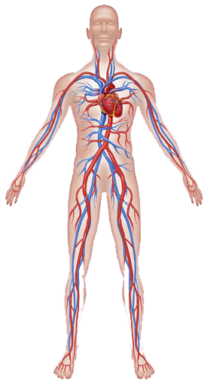Blood pressure.
4. Body temperature.

### Human Body

#### The circulatory system

In order for the body to work correctly, it needs nutrients and oxygen. These vital nutrients and oxygen are carried in the blood that is pumped throughout the body by the heart.

As the heart pumps, oxygenated blood flows out through the aorta, the largest artery in the body. All other arteries (red) branch out of the aorta and carry blood to the billions of cells in the body.

Once the blood has delivered the oxygen and nutrients to the body, it returns to the heart through the veins (blue). The oxygen depleted blood is then sent to the lungs to pick up more oxygen, remove carbon dioxide, and is returned to the heart where it is sent out to the body again. The movement of blood through the heart, lungs, and body is called “The Circulatory System.”

#### Coronary Arteries

Because the heart is a muscle, it needs oxygen and nutrients to work at optimum levels. The arteries that provide blood to the heart are called “Coronary Arteries” and are located directly on the heart. If these arteries become narrowed or blocked, treatment is necessary to restore blood flow.

#### Peripheral Vascular System

Coronary arteries aren’t the only arterial system susceptible to narrowing or blockage. Outside the heart is the peripheral vascular system, which includes:

* Carotid Arteries which supply blood to the brain
* Renal Arteries which supply blood to the kidneys
* Iliac Arteries which supply blood to the lower abdomen
* Femoral and Popliteal Arteries which supply blood to the legs

#### Heart Anatomy

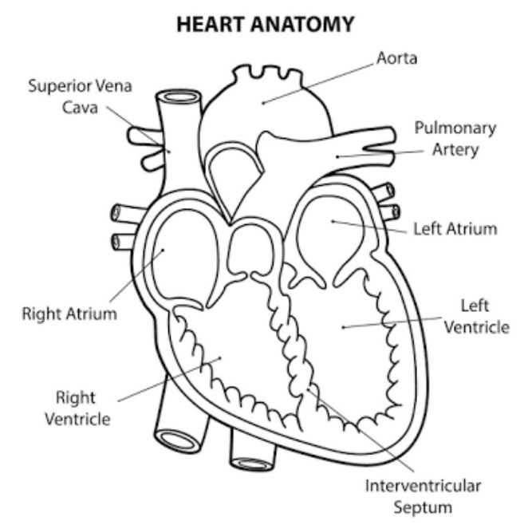The human heart is an organ that pumps blood throughout the body via the circulatory system, supplying oxygen and nutrients to the tissues and removing carbon dioxide and other wastes.

The heart has five surfaces: base (posterior), diaphragmatic (inferior), stern costal (anterior), and left and right pulmonary surfaces. It also has several margins: right, left, superior, and inferior:

* The right margin is the small section of the right atrium that extends between the superior and inferior vena cava.
* The left margin is formed by the left ventricle and left auricle.
* The superior margin in the anterior view is formed by both atria and their auricles.
* The Inferior margin is marked by the right ventricle.

Inside, the heart is divided into four heart chambers: two atria (right and left) and two ventricles

(Right and left).

The right atrium and ventricle receive deoxygenated blood from systemic veins and pump it to the lungs, while the left atrium and ventricle receive oxygenated blood from the lungs and pump it to the systemic vessels which distribute it throughout the body.

The left and right sides of the heart are separated by the interatrial and interventricular septa which are continuous with each other. Furthermore, the atria are separated from the ventricles by the atrioventricular septa. Blood flows from the atria into the ventricles through the atrioventricular orifices (right and left)–openings in the atrioventricular septa. These openings are periodically shut and open by the heart valves, depending on the phase of the heart cycle.

Although there are a lot of structures in the heart diagrams, you shall not worry, we’ve got them all covered for you in these articles and video tutorials. Be sure to check out our specially designed heart anatomy quiz which will help you to master the heart anatomy.

#### Heart Rate

HR is the rate at which the heart beats and affected by the expansion of the arterial wall with each every beat. The most prominent areas for the pulses are wrist (Radial artery), neck (Carotid- artery), inside of the elbow (Brachial artery), behind the knee (Popliteal artery) and ankle joint (Posterior artery).

The HR changes according to age and the physical and psychological impacts on the body. Higher pulse rate indicates the presence of abnormality in the body which can also be caused by other reasons such as anxiety, anger, excitement, emotion, and heart disorders. The pulse rate of an individual can help in determining various problems within the body, but it cannot be used lone to diagnose an abnormality.

The average heart rate is about 72 bpm for sedentary males and 80 bpm for sedentary females but these rates are often significantly different for trained athletes.

Table 2.4 Heart Rate and Respiratory Rate for Different Ages

|  |  |  |
| --- | --- | --- |
| Age | Heart Rate (BPM) | Respiratory Rate  (Breathes/min) |
| 0-5 months | 90-150 | 25-40 |
| 6-12 months | 80-140 | 20-30 |
| 1-3 years | 80-130 | 20-30 |
| 3-5 years | 80-120 | 20-30 |
| 6-10 years | 70-110 | 15-30 |
| 11-14 years | 60-105 | 12-20 |
| 14+ years | 60-100 | 12-20 |

**Effect of Temperature on Heart Function:**

Variations in body temperature can cause a greatly variations in heart rate in a proportional relationship. Decreased temperature can cause the HR to fall as low as a few beats per minute when a person is near death when the body temperature range of 60° to 70°F. These effects assure the fact that heat increases the permeability of the cardiac muscle membrane to ions that control heart rate, resulting in acceleration of the self-excitation process.

### Electrocardiograph

Electrical current flows from the heart and a small fraction of it makes it way to the body surface as the cardiac impulse go through the heart. Electrocardiograph or ECG for short detects and records these electrical signals that are responsible for pumping blood by the heart all around the body.

A normal electrocardiogram is shown in Figure.

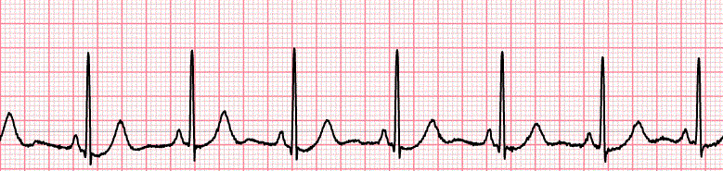

Figure 2.5 Normal ECG.

ECG is an indication of the patient’s heart health by recording the electrical activity to be read by specialized doctors which able to extract vital signs from it. Hence, HR can be calculated from ECG. [7]

### Photo plethysmograph

The PPG is a low-cost and portable technique that for measuring blood volume changes by collecting the variations in reflected or transmitted light. The blood pressure, blood oxygen saturation, HR, cardiac output recently and information of the cardiovascular system can be supplied with this technique. PPG experiences developments continuously, some researchers have used digital cameras and others a smart phone to detect HR by PPG technique.

However, overcoming the motion artifact is a huge challenge for PPG as it is sensitive it. Adaptive noise cancellation (ANC), which uses accelerometers as a noise reference, is proposed in order to help in reducing the affection of motion artifact.

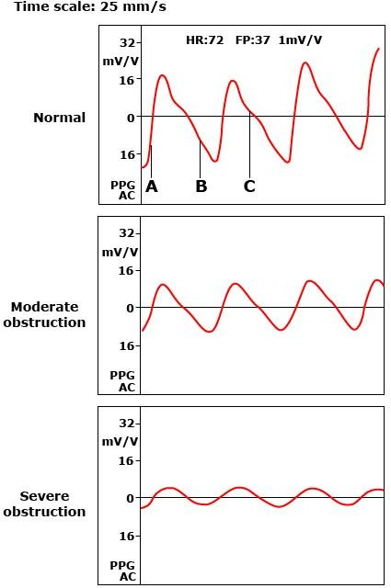

#### Figure 2.6 PPG of different conditions.

### Heart Attack

Cardiovascular diseases (CVDs) are disorders of the heart and blood vessels which they include:

1. Coronary heart disease which is a disease of the blood vessels supplying the heart muscle;
2. Cerebrovascular disease which is a disease of the blood vessels supplying the brain;
3. Peripheral arterial disease which is a disease of blood vessels supplying the arms and legs;
4. Rheumatic heart disease which is a damage to the heart muscle and heart valves from rheumatic fever, caused by streptococcal bacteria;
5. Congenital heart disease which is malformations of heart structure existing at birth;
6. Deep vein thrombosis and pulmonary embolism which is blood clots in the leg veins, which can dislodge and move to the heart and lungs.

Heart attacks and strokes are usually acute events and are mainly caused by a blockage that prevents blood from flowing to the heart or brain. The most common reason for this is a build-up of fatty deposits on the inner walls of the blood vessels that supply the heart or brain. Strokes can also be caused by bleeding from a blood vessel in the brain or from blood clots. The cause of heart attacks and strokes are usually the presence of a combination of risk factors, such as tobacco use, unhealthy diet and obesity, physical inactivity and harmful use of alcohol, hypertension, diabetes and hyperlipidemia.

The most important behavioral risk factors of heart disease are unhealthy diet, physical inactivity, tobacco use and harmful use of alcohol. These risks affect raised blood pressure, raised blood glucose, raised blood lipids, and overweight and obesity.

### Symptoms of Heart Attacks

Often, there are no symptoms of the underlying disease of the blood vessels. A heart attack or stroke may be the first warning of underlying disease. Symptoms of a heart attack include:

* Pain or discomfort in the center of the chest;
* Pain or discomfort in the arms, the left shoulder, elbows, jaw, or back.

In addition the person may experience difficulty in breathing or shortness of breath; feeling sick or vomiting; feeling light-headed or faint; breaking into a cold sweat; and becoming pale. Women are more likely to have shortness of breath, nausea, vomiting, and back or jaw pain. The most common symptom of a stroke is sudden weakness of the face, arm, or leg, most often on one side of the body.

Rheumatic heart disease is caused by damage to the heart valves and heart muscle from the inflammation and scarring caused by rheumatic fever. Rheumatic fever is caused by an abnormal response of the body to infection with streptococcal bacteria, which usually begins as a sore throat or tonsillitis in children.

Rheumatic fever mostly affects children in developing countries, especially where poverty is widespread. Globally, about 2% of deaths from cardiovascular diseases is related to rheumatic heart disease.

At least three quarters of the world's deaths from CVDs occur in low-and middle-income countries. That is due to people in these countries often does not have the benefit of integrated primary health care programs for early detection and treatment compared with high-income countries.

People in low- and middle-income countries who suffer from CVDs have less access to effective and equitable health care services which respond to their needs. As a result, many people are detected late in the course of the disease and die younger from CVDs.

At macro-economic level, CVDs place a heavy burden on the economies of low-and middle- income countries. To reduce the burden of CVD in low-income implemented even in low-resource settings have been identified by WHO for prevention and control of cardiovascular diseases. They include two types of interventions: population-wide and individual.

According to WHO, population-wide interventions that can be implemented to reduce CVDs include:

1. Comprehensive tobacco control policies
2. Taxation to reduce the intake of foods that are high in fat, sugar and salt
3. Building walking and cycle paths to increase physical activity
4. Strategies to reduce harmful use of alcohol
5. Providing healthy school meals to children.
6. Excess Acidity
7. Hyper tension

At the individual level, for prevention of first heart attacks and strokes, individual health-care interventions need to be targeted to those at high total cardiovascular risk or those with single risk factor levels above traditional thresholds, such as hypertension and hypercholesterolemia. The former approach is more cost-effective than the latter and has the potential to substantially reduce cardiovascular events. This approach is feasible in primary care in low-resource settings, including by non-physician health workers.

**CHAPTER 03**

# Chapter 03

## Specification and Implementation

## Hardware Design

### Circuit Diagram

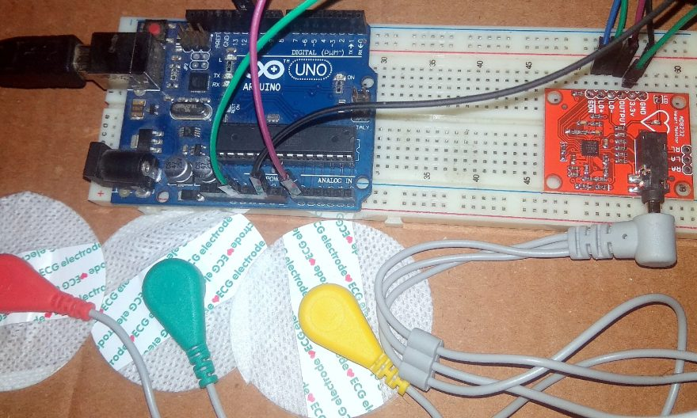

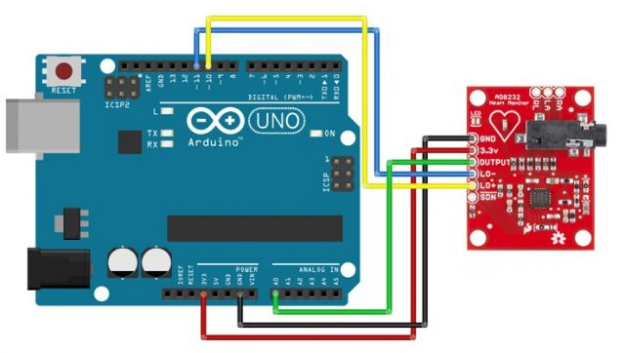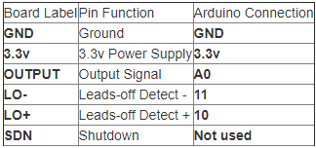

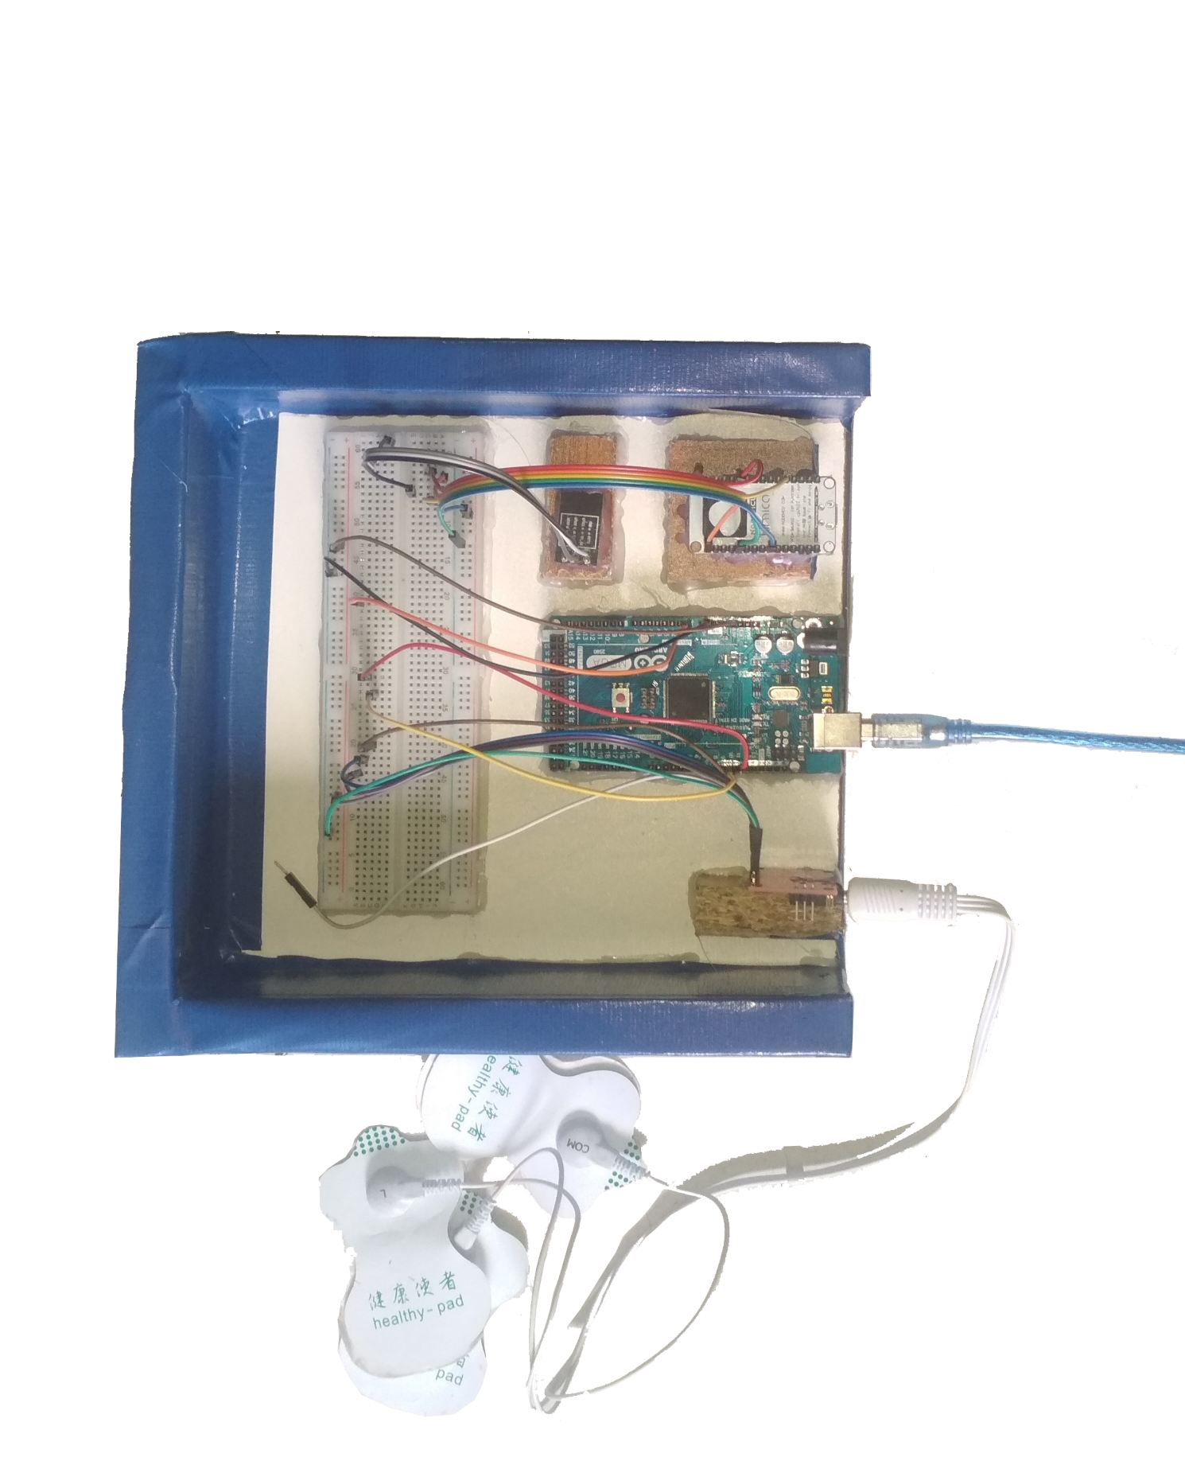

Existing Final Snap Shop of the Hardware

### Circuit Diagram Flowchart

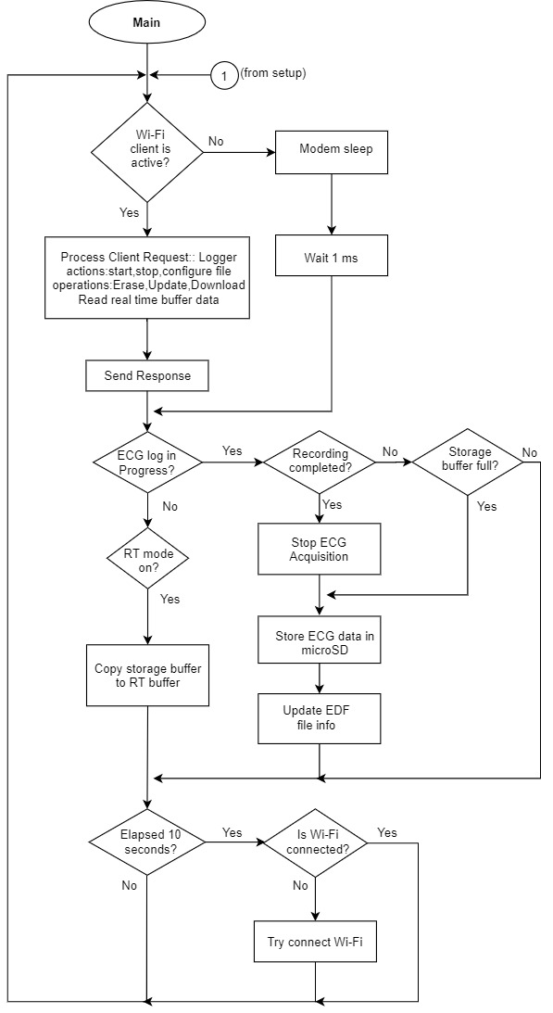

### Coding Part

*// initialize the serial communication:*

*Serial.begin(9600);*

*pinMode(10, INPUT); // Setup for leads off detection LO +*

*pinMode(11, INPUT); // Setup for leads off detection LO -*

*}*

*void loop() {*

*if((digitalRead(10) == 1)||(digitalRead(11) == 1)){*

*Serial.println('!');*

*}*

*else{*

*// send the value of analog input 0:*

*Serial.println(analogRead(A0));*

*}*

*//Wait for a bit to keep serial data from saturating*

*delay(1);*

*}*

*import processing.serial.*;*

*Serial myPort;        // The serial port*

*int xPos = 1;         // horizontal position of the graph*

*float height_old = 0;*

*float height_new = 0;*

*float inByte = 0;*

*int BPM = 0;*

*int beat_old = 0;*

*float[] beats = new float[500];  // Used to calculate average BPM*

*int beatIndex;*

*float threshold = 620.0;  //Threshold at which BPM calculation occurs*

*boolean belowThreshold = true;*

*PFont font;*

*void setup () {*

*// set the window size:*

*size(1000, 400);*

*// List all the available serial ports*

*println(Serial.list());*

*// Open whatever port is the one you're using.*

*myPort = new Serial(this, Serial.list()[2], 9600);*

*// don't generate a serialEvent() unless you get a newline character:*

*myPort.bufferUntil('\n');*

*// set inital background:*

*background(0xff);*

*font = createFont("Ariel", 12, true);*

*}*

*void draw () {*

*//Map and draw the line for new data point*

*inByte = map(inByte, 0, 1023, 0, height);*

*height_new = height - inByte;*

*line(xPos - 1, height_old, xPos, height_new);*

*height_old = height_new;*

*// at the edge of the screen, go back to the beginning:*

*if (xPos >= width) {*

*xPos = 0;*

*background(0xff);*

*}*

*else {*

*// increment the horizontal position:*

*xPos++;*

*}*

*// draw text for BPM periodically*

*if (millis() % 128 == 0){*

*fill(0xFF);*

*rect(0, 0, 200, 20);*

*fill(0x00);*

*text("BPM: " + inByte, 15, 10);*

*}*

*}*

*void serialEvent (Serial myPort)*

*{*

*// get the ASCII string:*

*String inString = myPort.readStringUntil('\n');*

*if (inString != null)*

*{*

*// trim off any whitespace:*

*inString = trim(inString);*

*// If leads off detection is true notify with blue line*

*if (inString.equals("!"))*

*{*

*stroke(0, 0, 0xff); //Set stroke to blue ( R, G, B)*

*inByte = 512;  // middle of the ADC range (Flat Line)*

*}*

*// If the data is good let it through*

*else*

*{*

*stroke(0xff, 0, 0); //Set stroke to red ( R, G, B)*

*inByte = float(inString);*

*// BPM calculation check*

*if (inByte > threshold && belowThreshold == true)*

*{*

*calculateBPM();*

*belowThreshold = false;*

*}*

*else if(inByte < threshold)*

*{*

*belowThreshold = true;*

*}*

*}*

*}*

*}*

*void calculateBPM ()*

*{*

*int beat_new = millis();    // get the current millisecond*

*int diff = beat_new - beat_old;    // find the time between the last two beats*

*float currentBPM = 60000 / diff;    // convert to beats per minute*

*beats[beatIndex] = currentBPM;  // store to array to convert the average*

*float total = 0.0;*

*for (int i = 0; i < 500; i++){*

*total += beats[i];*

*}*

*BPM = int(total / 500);*

*beat_old = beat_new;*

*beatIndex = (beatIndex + 1) % 500;  // cycle through the array instead of using FIFO queue*

*}*

## Software

### User Interface

External Interface Requirements

User Interfaces:

Login Form

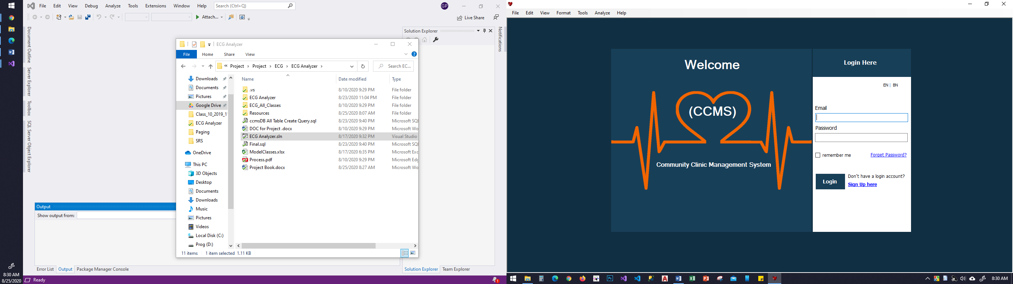

Dashboard

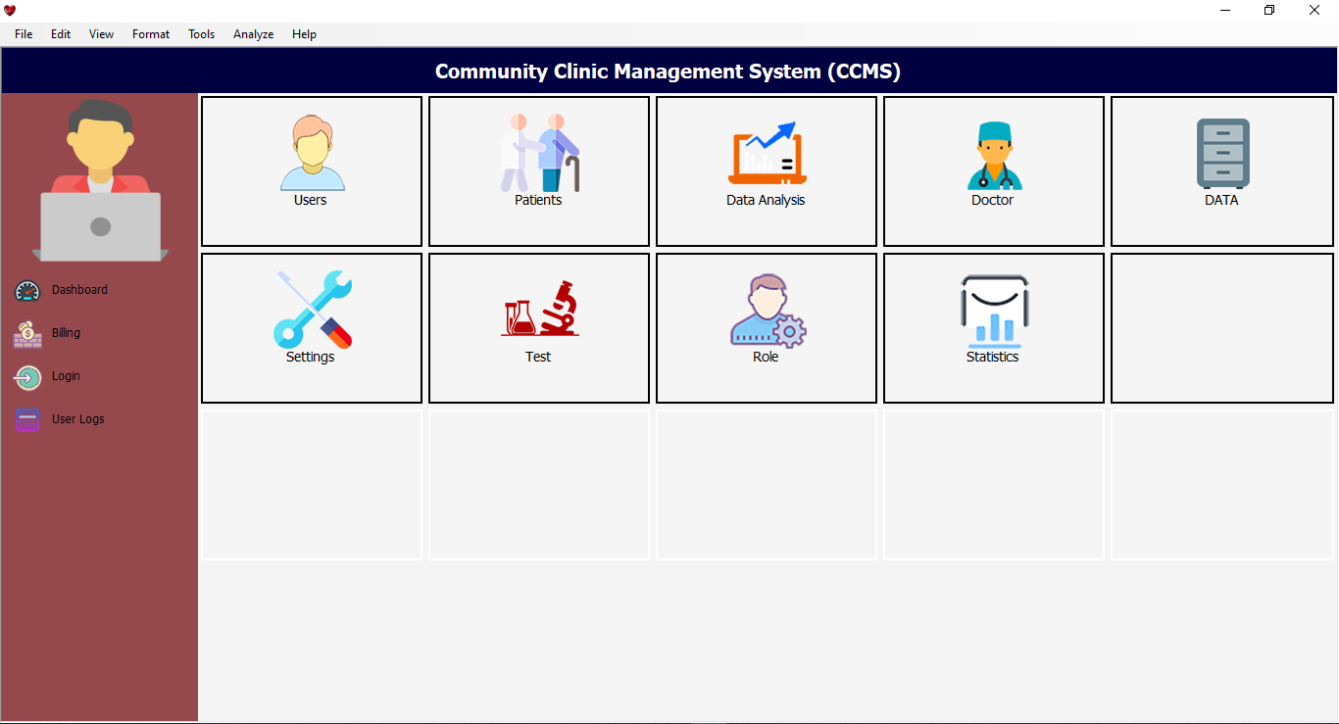

Data Analysis

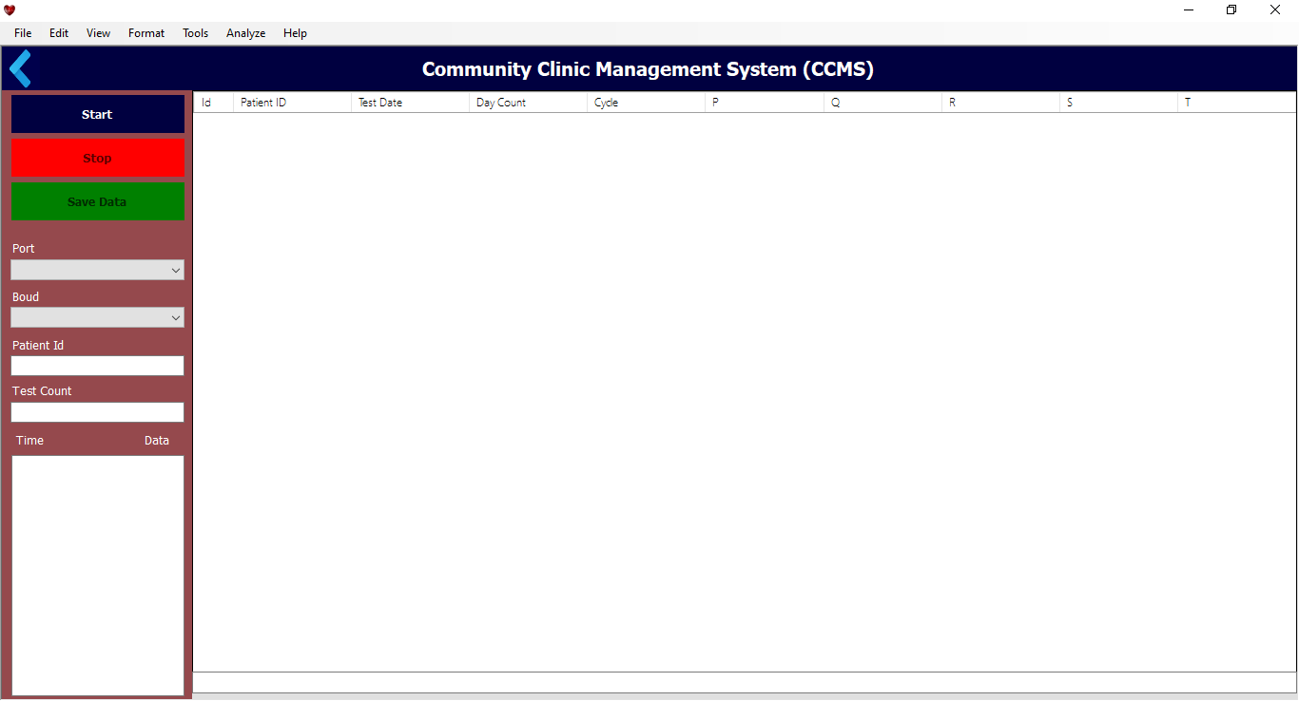

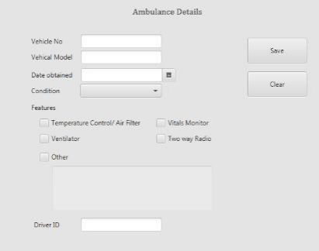

Emergency Treatment:

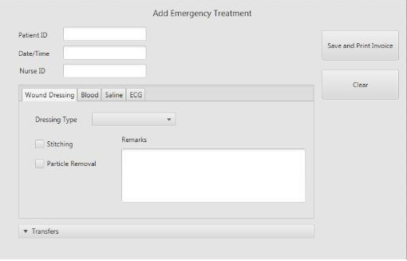

Add Employee Details

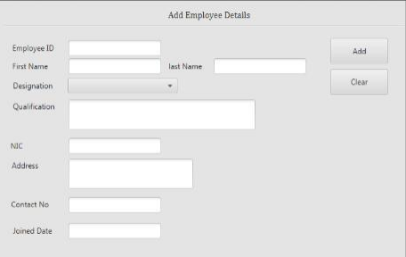

Add Medicine Details

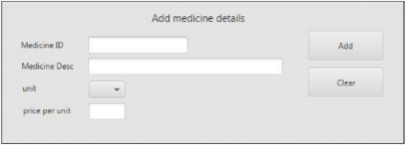

Add OPD Patient

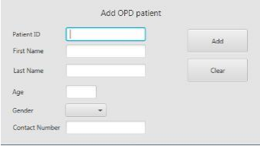

Add other member Details

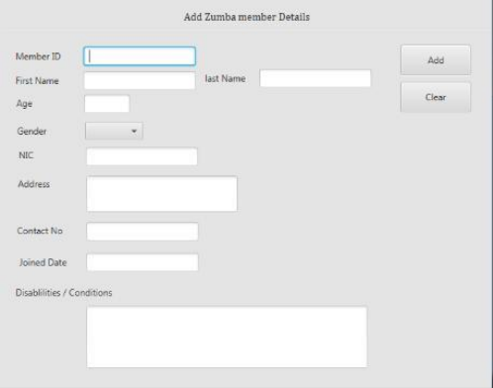

Employee Payroll Form

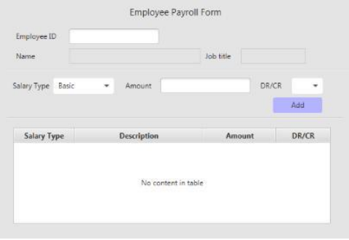

Test Result Entry Form

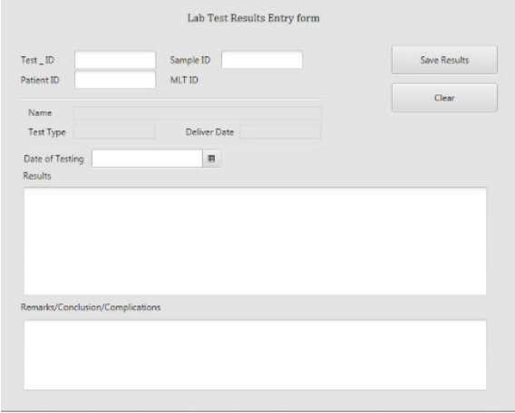

New Consultant Token Form

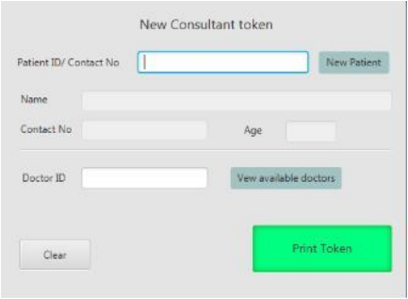

Pharmacy Receipt Form

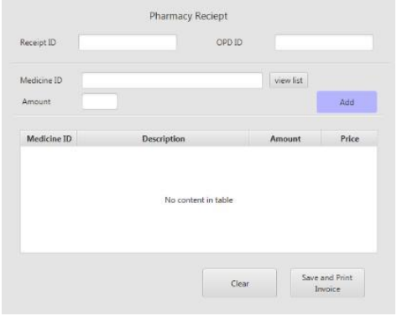

Test Sample Collection Form

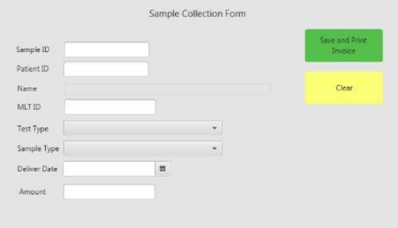

Some of Other Important Subordinate Form

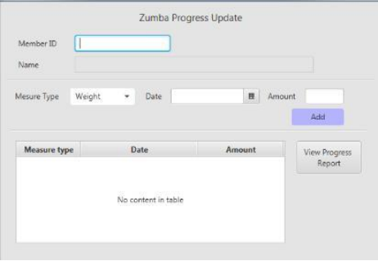

Patient Admission Form

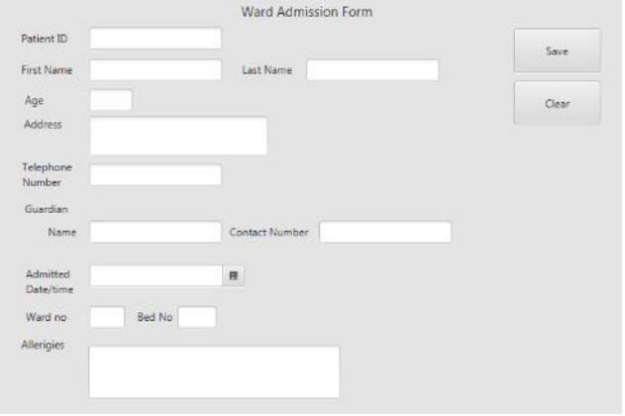

### **Flowchart**

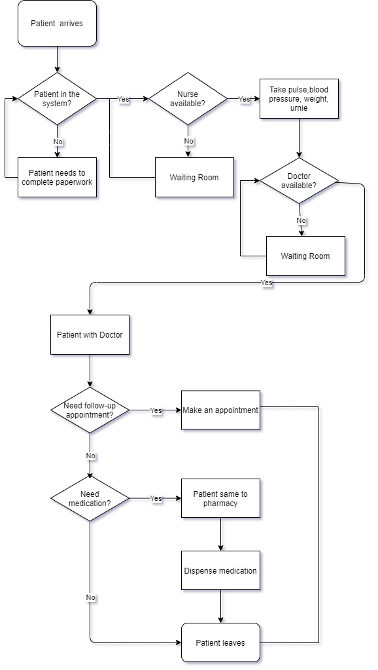

### **Algorithm**

#### Algorithm for community clinic management system (CCMS):

1. *Start*
2. *Check Database Exist or none*
3. *If Exist then Go to Step 5*
4. *If Database setting none then Open Setting page for Input Setting Information*
5. *Open Login page*
6. *If Login information exist*
7. *Go to Step 10*
8. *Open new User Registration page*
9. *Allocate memory for new User Information*
10. *Enter Username & Password*
11. *Open Dashboard Page*
12. *Open Existing Patient*
13. *If not exist Go to Step 14*
14. *Open new Patient registration page*
15. *Allocate memory for new patient information*
16. *Enter information*
17. *Create unique patient id as its NID*
18. *Create username and password*
19. *Create entry to the database*
20. *Allocate doctor for the patient*
21. *Tests and reports entry*
22. *Initiate advance fees*
23. *Allocation of bed and room for patient*
24. *Patient health progress*
25. *Patient discharge*
26. *Pending fees and updating*
27. *End*

#### Algorithm for ECG data analysis part:

1. *Start*
2. *Ready Hardware Device*
3. *Connect with Patient by proper Connection*
4. *Open Serial Port of Software*
5. *Select Baud and Port number as requirements*
6. *Start Button Click*
7. *If requirements are not fulfilled then go to STEP 5*
8. *Open Serial Port*
9. *Taking Data from Serial Port*
10. *Storing Data to rowDataList Array List*
11. *Treat all the item of rowDataList Array as rowDataItem*
12. *Create ISO Electric Line from rowDataList Array*
13. *Insert a 1st threshold value as r_threshold value to identify R data (**)*
14. *If rowDataItem enter R data then treat it as R data and add to RDataList Array*
15. *If rowDataItem exist ISO electric Line and Bellow the r_threshold value line then data will consider as P or T data.*
16. *Else rowDataItem bellow the ISO electric Line then data will consider as S or Q data.*
17. *Based on Timing P,T and S,Q data will define.*
18. *Save to Database*
19. *End*

### **MQTT box**

/*

Basic ESP8266 MQTT example

This sketch demonstrates the capabilities of the pubsub library in combination

with the ESP8266 board/library.

It connects to an MQTT server then:

- publishes "hello world" to the topic "outTopic" every two seconds

- subscribes to the topic "in Topic", printing out any messages

it receives. NB - it assumes the received payloads are strings not binary

- If the first character of the topic "inTopic" is an 1, switch ON the ESP Led,

else switch it off

It will reconnect to the server if the connection is lost using a blocking

reconnect function. See the 'mqtt_reconnect_nonblocking' example for how to

achieve the same result without blocking the main loop.

To install the ESP8266 board, (using Arduino 1.6.4+):

- Add the following 3rd party board manager under "File -> Preferences -> Additional Boards Manager URLs":

http://arduino.esp8266.com/stable/package_esp8266com_index.json

- Open the "Tools -> Board -> Board Manager" and click install for the ESP8266"

- Select your ESP8266 in "Tools -> Board"

*/

#### Code for MQTT Box

#include <ESP8266WiFi.h>

#include <PubSubClient.h>

// Update these with values suitable for your network.

const char* ssid = "Skyfall";

const char* password = "bond0007";

const char* mqtt_server = "broker.mqtt-dashboard.com";

WiFiClient espClient;

PubSubClient client(espClient);

long lastMsg = 0;

char msg[50];

int value = 0;

char set[35];

void setup_wifi() {

delay(10);

// We start by connecting to a WiFi network

//Serial.println();

//Serial.print("Connecting to ");

//Serial.println(ssid);

WiFi.begin(ssid, password);

while (WiFi.status() != WL_CONNECTED) {

delay(500);

//Serial.print(".");

}

randomSeed(micros());

//Serial.println("");

//Serial.println("WiFi connected");

//Serial.println("IP address: ");

//Serial.println(WiFi.localIP());

}

void callback(char* topic, byte* payload, unsigned int length) {

//Serial.print("Message arrived [");

//Serial.print(topic);

//Serial.print("] ");

for (int i = 0; i < length; i++) {

//Serial.print((char)payload[i]);

}

//Serial.println();

// Switch on the LED if an 1 was received as first character

if ((char)payload[0] == '1') {

digitalWrite(BUILTIN_LED, LOW); // Turn the LED on (Note that LOW is the voltage level

// but actually the LED is on; this is because

// it is active low on the ESP-01)

} else {

digitalWrite(BUILTIN_LED, HIGH); // Turn the LED off by making the voltage HIGH

}

}

void reconnect() {

// Loop until we're reconnected

while (!client.connected()) {

//Serial.print("Attempting MQTT connection...");

// Create a random client ID

String clientId = "ESP8266Client-";

clientId += String(random(0xffff), HEX);

// Attempt to connect

if (client.connect(clientId.c_str())) {

//

//Serial.println("connected");

// Once connected, publish an announcement...

int availableBytes = Serial.available();

for(int i=0; i<availableBytes; i++)

{

set[i] = Serial.read();

}

long now = millis();

if (now - lastMsg > 2000) {

lastMsg = now;

++value;

//set = String(Serial.read());

//msg = set + String(value);

snprintf (msg, 50, "#%s #%ld", set,value);

//Serial.print("Publish message: ");

//Serial.println(msg);

client.publish("STMM", msg);

}

client.publish("STMM", msg);

// ... and resubscribe

client.subscribe("inTopic");

} else {

//Serial.print("failed, rc=");

//Serial.print(client.state());

//Serial.println(" try again in 5 seconds");

// Wait 5 seconds before retrying

delay(2000);

}

}

}

void setup() {

pinMode(BUILTIN_LED, OUTPUT); // Initialize the BUILTIN_LED pin as an output

Serial.begin(115200);

setup_wifi();

client.setServer(mqtt_server, 1883);

client.setCallback(callback);

}

void loop() {

//Serial.begin(115200);

if (!client.connected()) {

reconnect();

}

String in;

delay(5000);

int availableBytes = Serial.available();

if(availableBytes > 0)

{

in = Serial.readStringUntil('\n');

}

for(int i=0; i < 30; i++)

{

set[i] = '\0';

}

for(int i=0; i<in.length(); i++)

{

set[i] = in.charAt(i);

}

long now = millis();

if (now - lastMsg > 2000) {

lastMsg = now;

++value;

//set = String(Serial.read());

//msg = set + String(value);

snprintf (msg, 50, "#%s #%ld", set,value);

//Serial.print("Publish message: ");

//Serial.println(msg);

client.publish("STMM", msg);

} client.loop();}

MQTT Box Protocol

**MQTT** is one of the most commonly used protocols in IoT projects. It stands for Message Queuing Telemetry Transport. In addition, it is designed as a lightweight messaging protocol that uses publish/subscribe operations to exchange data between clients and the server.[21]

#### How MQTT works

Like any other internet protocol, MQTT is based on clients and a server. Likewise, the server is the guy who is responsible for handling the client’s requests of receiving or sending data between each other.

MQTT server is called a broker and the clients are simply the connected devices.  
So:

1. When a device (a client) wants to send data to the broker, we call this operation a “publish”.
2. When a device (a client) wants to receive data from the broker, we call this operation a “subscribe”.

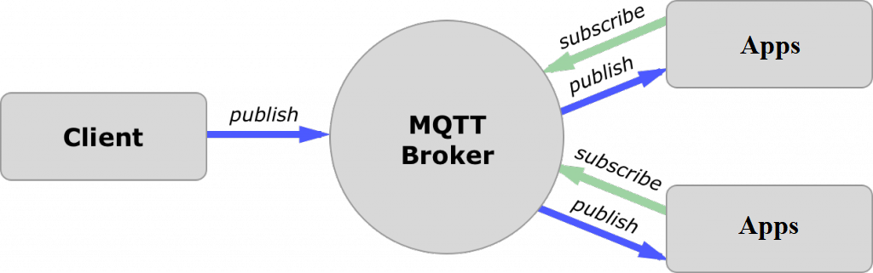

In addition, these clients are publishing and subscribing to topics. So, the broker here is the one that handles the publishing/subscribing actions to the target topics.

#### Example:

Let’s say there is some devices like Heartrate and ECG sensor. Certainly, it wants to send his readings to the broker. On the other side, a phone/desktop application wants to receive this result. Therefore, 2 things will happen:

* The device defines the topic it wants to publish on, ex: “Heartrate”, ”ECG”. Then, it publishes the message “Heartrate and ECG value”.
* The phone/desktop application subscribes to the topic “Heartrate”, ”ECG”. Then, it receives the message that the device has published, which is the Heartrate and ECG value.

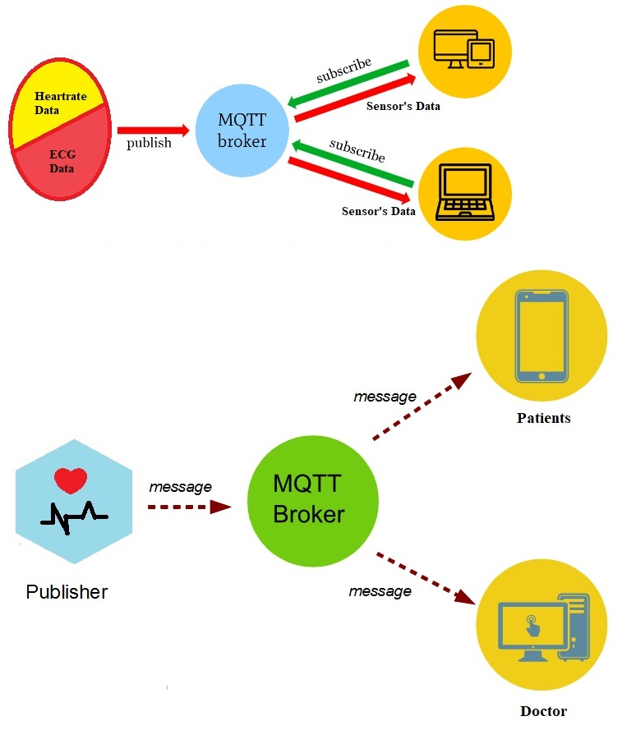Again, the broker role here is to take the message “Heartrate and ECG value” and deliver it to phone/desktop application

**CHAPTER 04**

# Chapter 04

## Implementation

This project has been developed with Arduino microcontroller connected with sensors which are attached to the patient. All the sensors and location data sent from microcontroller to Community Clinic Management System (CCMS) to MSSQL database. A doctor or guardian can log in to web portal to monitor patient’s data at any point in time. In case of emergencies, like temperature spike or heartbeat spike or detection of toxic gas etc. an SMS and email alert sent to doctor and guardian’s mobile and email 33 respectively. And at any point of time either a doctor or guardian can log into web portal with patient unique credentials and can track patient’s location which would help medical services to send appropriate help in case of emergencies.

### 4.1 Arduino Micro controller Unit

➢ Gsm_init(): With this event, Arduino board checks out network connectivity before fetching sensor data and relay it to cloud. Below Algorithm in Arduino board executes series of AT commands which would check network connectivity and enables internet.

### 4.2 Location Tracking

➢ GpsEvent(): With this event, GPRS module in board fetch’s current location coordinates. In this algorithm below, gpsEvent fetch’s data from GPRS module and parse it to get exact location coordinates.

### 4.3 Sending data to MSSQL database server

➢ Gprs_send(): This event sends the sensor data using GSM module to cloud through AT+HTTPPARA command i.e. this event sends all the sensor data to MySQL database server which later PHP API fetch’s data from server and relays information on web page.

### 4.4 Sending SMS alert

➢ AT+CMGS command: Arduino board sends SMS alert using GSM module

### 4.5 Sending Email alert

➢ Mail(): C# code analyses the data from server and sends email alert on emergencies while relaying patient data to server. Email alert consists of message about condition which failed like temperature spikes, fall detection, heartbeat failure etc. along with link to patient web page. On click link will be redirected to patient web page where doctor and care taker can view patient vitals and current location of patient.Components it is very important to know all the details about both hardware specifications for starting the project all ingredient’s Ares follows:

* 1. Arduino MEGA ATmega2560
  2. Sensors (i) ECG AD8232 (ii) Heartbeat sensor MAX30100
  3. Jumper wires
  4. Breadboard
  5. Laptop/ computer
  + Arduino Mega 2560 Board

Arduino board is an open-source microcontroller board which is based on Atmega 2560 microcontroller. The growth environment of this board executes the processing or wiring language. These boards have recharged the automation industry with their simple to utilize platform wherever everybody with small otherwise no technical backdrop can start by discovering some necessary skills to program as well as run the [Arduino board](https://www.elprocus.com/arduino-basics-and-design/). These boards are used to extend separate interactive objects otherwise we can connect to software on your PC like MaxMSP, Processing, and Flash. This article discusses an introduction to Arduino mega 2560 board, pin diagram and its specifications.

What is an Arduino Mega 2560?

The microcontroller board like “Arduino Mega” depends on the ATmega2560 microcontroller. It includes digital input/output pins-54, where 16 pins are analog inputs, 14 are used like PWM outputs hardware serial ports ([UARTs](https://www.elprocus.com/basics-of-uart-communication-block-diagram-applications/)) – 4, a [crystal oscillator](https://www.elprocus.com/crystal-oscillator-circuit-and-working/)-16 MHz, an ICSP header, a power jack, a USB connection, as well as an RST button. This board mainly includes everything which is essential for supporting the microcontroller. So, the power supply of this board can be done by connecting it to a PC using a USB cable, or battery or an AC-DC adapter. This board can be protected from the unexpected electrical discharge by placing a base plate.

The SCL & SDA pins of Mega 2560 R3 board connects to beside the AREF pin. Additionally, there are two latest pins located near the RST pin. One pin is the IOREF that permit the shields to adjust the voltage offered from the Arduino board. Another pin is not associated & it is kept for upcoming purposes. These boards work with every existing shield although can adjust to latest shields which utilize these extra pins.

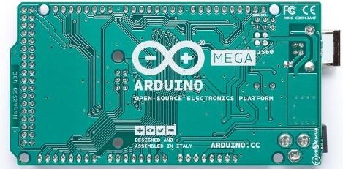Arduino Mega

Specifications:

The specifications of Arduino Mega include the following.

* The ATmega2560 is a Microcontroller
* The operating voltage of this microcontroller is 5volts
* The recommended Input Voltage will range from 7volts to 12volts
* The input voltage will range from 6volts to 20volts
* The digital input/output pins are 54 where 15 of these pins will supply PWM o/p.
* Analog Input Pins are 16
* DC Current for each input/output pin is 40 mA
* DC Current used for 3.3V Pin is 50 mA
* Flash Memory like 256 KB where 8 KB of flash memory is used with the help of bootloader
* The static random-access memory (SRAM) is 8 KB
* The electrically erasable programmable read-only memory (EEPROM) is 4 KB
* The clock (CLK) speed is 16 MHz
* The USB host chip used in this is MAX3421E
* The length of this board is 101.52 mm
* The width of this board is 53.3 mm
* The weight of this board is 36 g

Arduino Mega Pin Configuration

The pin configuration of this Arduino mega 2560 board is shown below. Every pin of this board comes by a particular function which is allied with it. All analog pins of this board can be used as digital I/O pins. By using this board, the Arduino mega projected can be designed. These boards offer flexible work memory space is the more & processing power that permits to work with different types of sensors without delay. When we compare with other types of Arduino boards, these boards are physically superior.

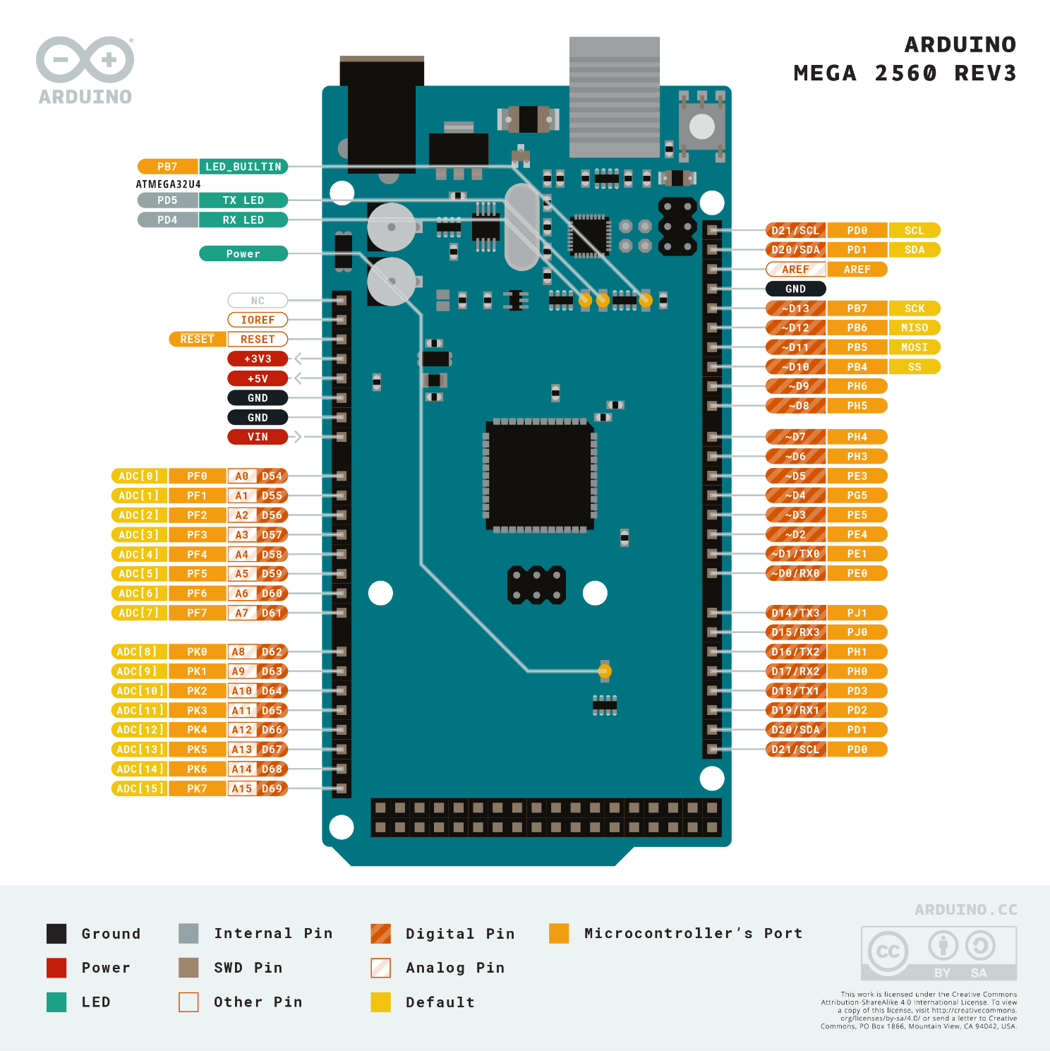

These pins are used for providing o/p regulated voltage approximately 5V. This RPS (regulated power supply) provides the power to the microcontroller as well as other components which are used over the Arduino mega board. It can be attained from Vin-pin of the board or one more regulated voltage supply-5V otherwise USB cable, whereas another voltage regulation can be offered by 3.3V0-pin. The max power can be drawn by this is 50mA.

GND Pin

The Arduino mega board includes 5-GND pins where one of these pins can be used whenever the project requires.

**Reset (RST) Pin**

The RST pin of this board can be used for rearranging the board. The board can be rearranged by setting this pin to low.

**Vin Pin**

The range of supplied input voltage to the board ranges from 7volts to 20volts. The voltage provided by the power jack can be accessed through this pin. However, the output voltage through this pin to the board will be automatically set up to 5V.

**Serial Communication**

The serial pins of this board like TXD and RXD are used to transmit & receive the serial data. Tx indicates the transmission of information whereas the RX indicates receive data. The serial pins of this board have four combinations. For serial 0, it includes Tx (1) and Rx (0), for serial 1, it includes Tx(18) & Rx(19), for serial 2 it includes Tx(16) & Rx(17), and finally for serial 3, it includes Tx(14) & Rx(15).

**External Interrupts**

The external interrupts can be formed by using 6-pins like interrupt 0(0), interrupt 1(3), interrupt 2(21), interrupt 3(20), interrupt 4(19), interrupt 5(18). These pins produce interrupts by a number of ways i.e. Providing LOW value, rising or falling edge or changing the value to the interrupt pins.

**LED**

This Arduino board includes a [LED](https://www.elprocus.com/mains-operated-led/) and that is allied to pin-13 which is named as digital pin 13. This LED can be operated based on the high and low values of the pin. This will give you to modify the programming skills in real time.

**AREF**

The term AREF stands for Analog Reference Voltage which is a reference voltage for analog inputs

**Analog Pins**

There are 16-analog pins included on the board which is marked as A0-A15. It is very important to know that all the analog pins on this board can be utilized like digital I/O pins. Every analog pin is accessible with the 10-bit resolution which can gauge from GND to 5 volts. But the higher value can be altered using AREF pin as well as the function of analog Reference ().

**I2C**

The [I2C communication](https://www.elprocus.com/i2c-bus-protocol-tutorial-interface-applications/) can be supported by two pins namely 20 & 21 where 20-pin signifies Serial Data Line (SDA) which is used for holding the data & 21-pin signifies Serial Clock Line (SCL ) mostly utilized for offering data synchronization among the devices

**SPI Communication**

The term SPI is a serial peripheral interface which is used to transmit the data among the controller & other components. Four pins like MISO (50), MOSI (51), SCK (52), and SS (53) are utilized for [the communication](https://www.elprocus.com/avr-microcontroller-serial-data-communication/) of SPI.

**Dimensions**

The dimension of Arduino Mega 2560 board mainly includes the length as well as widths like 101.6mm or 4-inch X 53.34 mm or 2.1 inches. It is comparatively superior to other types of boards which are accessible in the marketplace. But the power jack and USB port are somewhat expanded from the specified measurements.

**Shield Compatibility**

Arduino Mega is well-suited for most of the guards used in other Arduino boards. Before you propose to utilize a guard, confirm the operating voltage of the guard is well-suited with the voltage of the board. The operating voltage of most of the guards will be 3.3V otherwise 5V. But, guards with high operating voltage can injure the board.

In addition, the distribution header of the shield should vibrate with the distribution pin of the Arduino board. For that, one can connect the shield simply with the Arduino board & make it within a running state.

**Programming**

The programming of an Arduino Mega 2560 can be done with the help of an IDE (Arduino Software), and it supports C-programming language. Here the sketch is the code in the software which is burned within the software and then moved to the Arduino board using a USB cable.

An Arduino mega board includes a boot loader which eliminates an external burner utilization to burn the program code into the Arduino board. Here, the communication of the boot loader can be done using an STK500 protocol.

When we compile as well as burn the Arduino program, then we can detach the USB cable to remove the power supply from the Arduino board. Whenever you propose to use the Arduino board for your project, the power supply can be provided by a power jack otherwise Vin pin of the board.

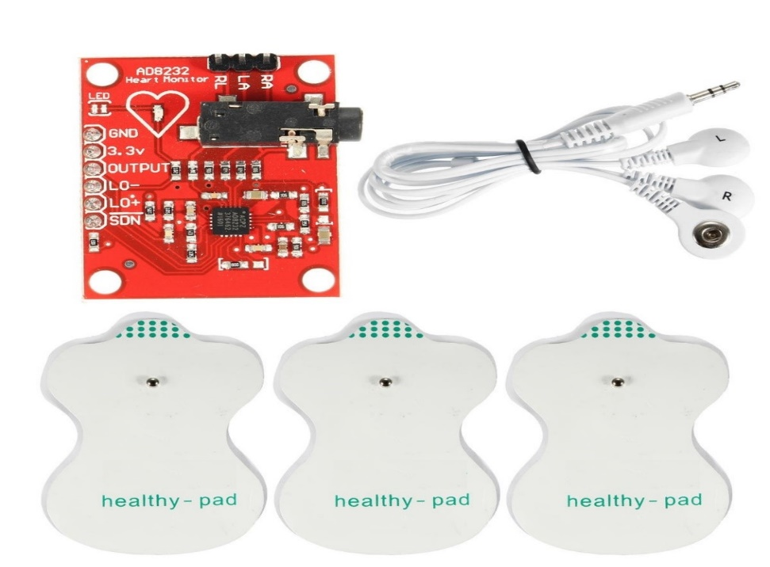Another feature of this is multitasking wherever Arduino mega board comes handy. But Arduino IDE Software doesn’t support multi-tasking however one can utilize additional operating systems namely RTX & Free RTOS to write C-program for this reason. This is flexible to use in your personal custom build program with the help of an ISP connector.

Thus, this is all about an Arduino Mega 2560 datasheet. It is a substitution of the older Arduino Mega board. Because of the number of pins, usually, it is not utilized for general projects however we can discover them in complex projects such as temperature sensing, 3D printers, IOT applications, radon detectors, monitoring of real-time data applications, etc.

(i) ECG Sensor

|  |  |  |
| --- | --- | --- |
| Board Label | Pin Function | Arduino Connection |
| GND | Ground | GND |
| 3.3v | 3.3v Power Supply | 3.3v |
| OUTPUT | Output Signal | A0 |
| LO- | Leads-off Detect - | 11 |
| LO+ | Leads-off Detect + | 10 |
| SDN | Shutdown | Not used |

An ECG Sensor with disposal electrodes attaches directly to the chest to detect every heartbeat. The electrodes of ECG sensor will convert heart beat to electric signal. ECG sensor is very light weight, slim and accurately to measures continuous heart beat and shows data rate of heart beat. The AD8232 is a little chip used to measure the electrical activity of the heart. The electrical activity can be charted as an ECG or Electrocardiogram. Electrocardiography is used to help diagnose various heart conditions.[3] Features the AD8232 heart monitor has 9 connection pins in the IC. They are Ground (GD), 3.3 V power supply, output signal, leads of detect (LO -), leads of detect (LO+), shutdown (SDN), Ra (input 1), LA (input 2), RL (input 3). This kit has also 3 cables.

Pin configuration and function descriptions

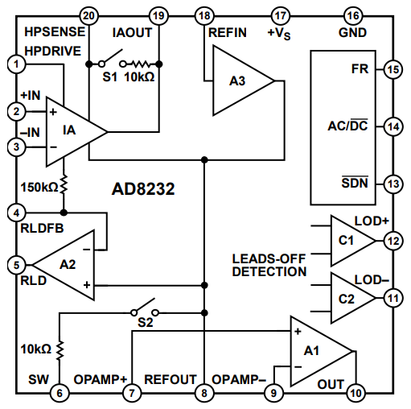

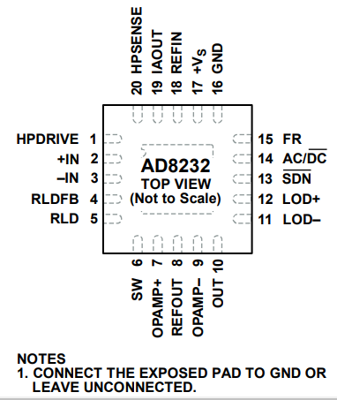

Pin Function Descriptions

|  |  |  |
| --- | --- | --- |
| **Pin No.** | Mnemonic | Description |
| **1** | HPDRIVE | High-Pass Driver Output. Connect HPDRIVE to the capacitor in the first high-pass filter. The AD8232 drives this pin to keep HPSENSE at the same level as the reference voltage. |
| **2** | +IN | Instrumentation Amplifier Positive Input. +IN is typically connected to the left arm (LA) electrode. |
| **3** | −IN | Instrumentation Amplifier Negative Input. −IN is typically connected to the right arm (RA) electrode. |
| **4** | RLDFB | Right Leg Drive Feedback Input. RLDFB is the feedback terminal for the right leg drive circuit. |
| **5** | RLD | Right Leg Drive Output. Connect the driven electrode (typically, right leg) to the RLD pin. |
| **6** | SW | Fast Restore Switch Terminal. Connect this terminal to the output of the second high-pass filter. |
| **7** | OPAMP+ | Operational Amplifier Noninverting Input. |
| **8** | REFOUT | Reference Buffer Output. The instrumentation amplifier output is referenced to this potential. Use REFOUT as a virtual ground for any point in the circuit that needs a signal reference. |
| **9** | OPAMP− | Operational Amplifier Inverting Input. |
| **10** | OUT | Operational Amplifier Output. The fully conditioned heart rate signal is present at this output. OUT can be connected to the input of an ADC. |
| **11** | LOD− | Leads Off Comparator Output. In dc leads off detection mode, LOD− is high when the electrode to −IN is disconnected, and it is low when connected. In ac leads off detection mode, LOD− is always low. |
| **12** | LOD+ | Leads Off Comparator Output. In dc leads off detection mode, LOD+ is high when the +IN electrode is disconnected, and it is low when connected. In ac leads off detection mode, LOD+ is high when either the −IN or +IN electrode is disconnected, and it is low when both electrodes are connected. |
| **13** | SDN | Shutdown Control Input. Drive SDN low to enter the low power shutdown mode. |
| **14** | AC/DC | Leads Off Mode Control Input. Drive the AC/DC pin low for dc leads off mode. Drive the AC/DC pin high for ac leads off mode. |
| **15** | FR | Fast Restore Control Input. Drive FR high to enable fast recovery mode; otherwise, drive it low. |
| **16** | GND | Power Supply Ground. |
| **17** | +Vs | Power Supply Terminal. |
| **18** | REFIN | Reference Buffer Input. Use REFIN, a high impedance input terminal, to set the level of the reference buffer. |
| **19** | IAOUT | Instrumentation Amplifier Output Terminal. |
| **20** | HPSENSE | High-Pass Sense Input for Instrumentation Amplifier. Connect HPSENSE to the junction of R and C that sets the corner frequency of the dc blocking circuit. |
| **21** | EP | Exposed Pad. Connect the exposed pad to GND or leave it unconnected. |

Design overview

The AD8232 is an integrated front end for signal conditioning of cardiac bio potentials for heart rate monitoring. It consists of a specialized instrumentation amplifier (IA), an operational amplifier (A1), a right leg drive amplifier (A2), and a misapply reference buffer (A3). In addition, the AD8232 includes leads off detection circuitry and an automatic fast restore circuit that brings back the signal shortly after leads are reconnected. The AD8232 contains a specialized instrumentation amplifier that amplifies the ECG signal while rejecting the electrode half-cell potential on the same stage. This is possible with an indirect current feedback architecture, which reduces size and power compared with traditional implementations

**(ii) Heartbeat Sensor**

**We are using MAX30100 heart rate blood oxygen concentration sensor module. This heart beat sensor is a plug and play heart rate sensor for Arduino. It is an electronic device that is used to measure the heart rate i.e. speed of the heartbeat. Heart Rate can be monitored in two ways: one way is to manually check the pulse either at wrists or neck and the other way is to use a Heartbeat Sensor. It sips power with just 4mA current draws at 3.3v.**

Optical sensor: IR and red LED combined with photodetector Measures absorbance of pulsing blood. Motion artefact resilience. Ambient light cancellation. Ready-to-use examples save development time.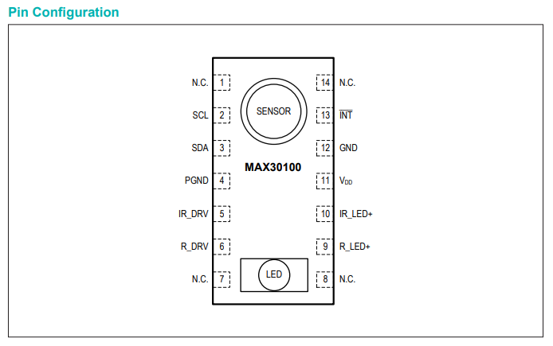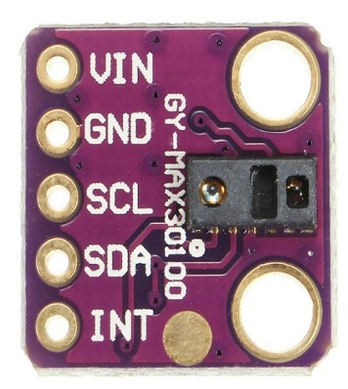 MAX30100 is a pulse oximeter and heart-rate sensor integrated circuit (IC) for wearable health monitoring systems or devices.

It detects pulse oximetry and heart rate signals with a combination of two LEDs (red and infra-red), a photodetector, optimized optics, and low-noise analog signal processing techniques. It can operate from either 1.8V or 3.3V power supplies and can be powered down programmatically by software with negligible standby current, thereby presenting the possibility of leaving the power supply connected all the time. It is typically used in fitness assistant devices, medical monitoring devices and wearable devices. Figure 9 below shows the pin configuration of MAX30100 and the top and bottom views of the chip. The LEDs (red and infra-red) are located on top while the pins are located at the bottom.

|  |  |  |
| --- | --- | --- |
| PIN | NAME | FUNCTION |
| 1, 7, 8, 14 | N.C. | No Connection. Connect to PCB Pad for Mechanical Stability. |
| 2 | SCL | I2C Clock Input |
| 3 | SDA | I2C Clock Data, Bidirectional (Open-Drain) |
| 4 | PGND | Power Ground of the LED Driver Blocks |
| 5 | IR_DRV | IR LED Cathode and LED Driver Connection Point. Leave floating in circuit. |
| 6 | R_DRV | Red LED Cathode and LED Driver Connection Point. Leave floating in circuit. |
| 9 | R_LED+ | Power Supply (Anode Connection) for Red LED. Bypass to PGND for best performance. Connected to IR_LED+ internally. |
| 10 | IR_LED+ | Power Supply (Anode Connection) for IR LED. Bypass to PGND for best performance. Connected to R_LED+ internally. |
| 11 | VDD | Analog Power Supply Input. Bypass to GND for best performance. |
| 12 | GND | Analog Ground |
| 13 | INT | Active-Low Interrupt (Open-Drain) |

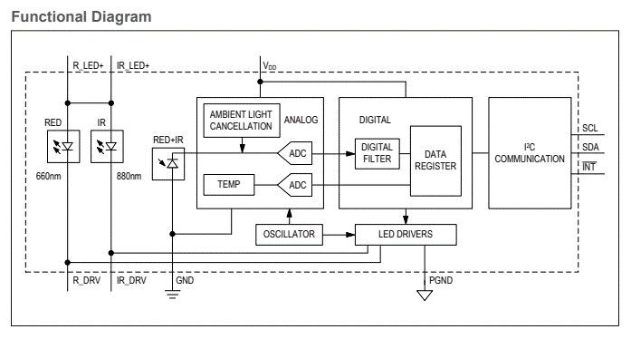

Main Features

MAX30100 is a complete pulse oximeter and heart-rate sensor solution on a single die. With its LEDs (red and infra-red), photo sensor and high-performance Analog Front- 14 End all integrated in a single chip, it is very simple and convenient to use. Its form factor, 5.6mm x 2.8mm x 1.2mm 14-Pin Optically Enhanced System-in-Package, makes it suitable for wearable devices. [16, 1]. For efficient power management and savings, it has programmable sample rate and LED current, and ultra-low shutdown current (typically 0.7µA). Other important features include high Signal to Noise Ratio (SNR), integrated ambient light cancellation, and high sample rate capability. Suitability for Project At the beginning of this project, MAX30100 was about the only heart-rate monitor sensor solution I could access that offered an integrated LED, photodetector and signal filtering and processing units, all in a single die. This made it preferable among other similar sensors available. Furthermore, it comes in a relatively small form packaging and promises a high signal to noise ratio (SNR) which is very important for cleaner and more reliable signal. All this, together with all the other features listed above, formed the basis for its suitability for the project.[6]

Detailed Description

The MAX30100 is a complete pulse oximetry and heart rate sensor system solution designed for the demanding requirements of wearable devices. The MAX30100 provides very small total solution size without sacrificing optical or electrical performance. Minimal external hardware components are needed for integration into a wearable device.

The MAX30100 is fully configurable through software registers, and the digital output data is stored in a 16-deep FIFO within the device. The FIFO allows the MAX30100 to be connected to a microcontroller or microprocessor on a shared bus, where the data is not being read continuously from the device’s registers

Jumper Wire

Jumper wires are used for making connections between items on the PCB and Arduino’s header pins. It is required to use them to wire up all the circuits.

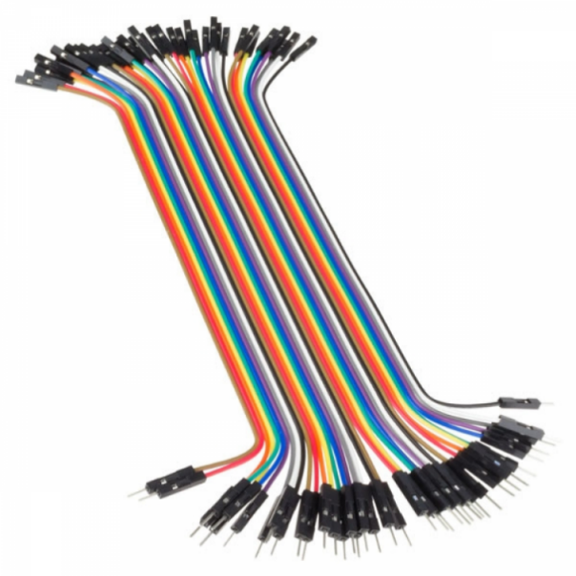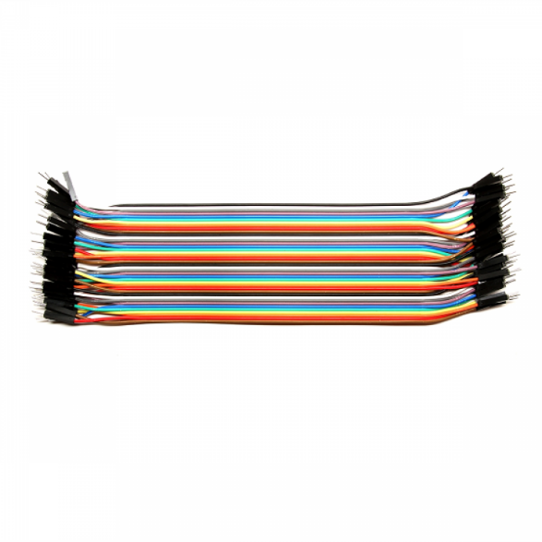

Breadboard

This is a half-size solderless breadboard with 400 tie points. It has a standard double-strip in the middle and two power rails on both sides. You can just put these solderless breadboards together either way to make a longer and/or wider breadboard.

**Breadboard size:**16.5 x 5.4 x 1cm/ 6.5″ x 2.1″ x 0.39″ (L*W*T)

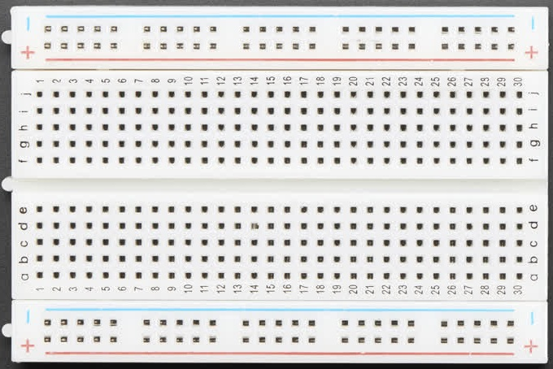

## Software Requirement Specification (SRS)

### PURPOSE

The purpose of this document is to build a Community Clinic Management System (CCMS) to manage Patient, Doctor, Employee, Role and all of the Data of the Specific Diagnostics and health Tests.

### DOCUMENT CONVENTIONS

This document uses the following conventions.

|  |  |
| --- | --- |
| DB | MSSQL |
| DDB | Distributed Database |
| ER | Entity Relationship |
| IDE | Visual Studio 16.4.7 |
| Framework | .Net Framework |

### INTENDED AUDIENCE AND READING SUGGESTIONS

This Software Requirements Specification document is intended for software engineers, system testers and software designers in developing, testing, and producing the CCMS and for the project. It is suggested to read the sections sequentially, and to reference the appendices as one progresses, in order to clarify jargon terms and definitions.

**1.4 PROJECT SCOPE**

This SRS details the development of the Community Clinic Management System (CCMS) project and the five subsystems. This project is open source and shall be available to modification at no restriction from EUB. EUB is not responsible or liable for any changes made to this project outside of its initial release. The scope of the RIS subsystem is to create a generic FOSS RIS program, which can be customized for deployment and integration into any Community Clinic System use; however, once developed, the RIS will be customized to the needs of our client, Allegheny Health Network. The PACS scope is to create an archive and communication system that covers how medical pictures are gathered, stored, shared amongst medical professionals, and secured for confidentiality. The scope of the IAM subsystem is to create a system that shall control all image acquisition devices processed by a hospital. The desired system combines several different software controlling systems into one system capable of running numerous types of imaging devices, further reducing training time and creating a more efficient imaging department. The HIS scope is to assist privileged users to make decisions needed for health or financial issues relating to the patients in the database. This subsystem shall also provide the users with organization and access to easy accurate information. The ADT/PRS subsystem is to streamline the process of handling patient data. A patient’s information is store and share with the appropriate people automatically under this subsystem.

### OVERALL DESCRIPTION

#### PRODUCT PERSPECTIVE

The Community Clinic Management System (CCMS) is an open source system comprising of five different subsystems. The five subsystems are as follow: The FOSS RIS project is a separate program, which is a component of a larger FOSS Hospital Management System (HMS), similar to how Microsoft Word is a separate program inside Microsoft Office suite. In the FOSS HMS system, the FOSS RIS program performs all HIS operations. The RIS module uses the shared, global variables, enums, framework, and used to create the other FOSS HIS program components, just like with Microsoft Office. All data exclusive to the RIS module will be programmed in the RIS module. Hospital Information System will replace all traditional and outdated means of tracking patient information and other data useful to the hospital. A Hospital Information System shall replace forms of databases using manual or outdated hardcopy databases. Accessing data can be better monitored, organized, and time conscientious. The IAM program shall be a new management system which shall make individual systems obsolete. It shall allow one program to control all the different image acquisition devices and shall interact with the other components of the hospital management system being designed. The driving principle of this PACS is to automate and provide the infrastructure to digitally control the storage and transportation of images taken with compatible devices within a general hospital. The ADT/PRS subsystem stores patient data, which other subsystems can access as required. This is accomplished by granting the other systems access to this subsystem’s patient database.

#### Product Features

the SHMS has five subsystems and these subsystems shall perform the following features: • The RIS subsystem shall include patient list management, radiology department workflow management, request and document x-ray scanning, result entry, and reporting and printout/faxing and emailing of clinical reports. • The PACS subsystem shall perform image importing/capturing, image encryption, local image storage, remote image retrieval, image compression, image display, and image processing. • The HIS subsystem shall contain a secure database. The database GUI shall be user friendly for all staff members and properly enter/obtain/modify patient information. The DB shall utilize the token authentication for secure access and will be relative in size and flexibility of the data demand. • The IAM subsystem shall have a simple user interface which allows the user to log in then access any imaging device connected to the imaging intranet, select what type of device and then which specific device within the hospital they will use. The images shall be controlled from one console and share these images with the hospital patient database. The ADT/PRS subsystem shall allow an administrator to enter patient information, such as name, age, etc. That information is then stored, and shared with other users as appropriate. It shall also alert the medical staff when a patient that requires different treatment is admitted, such as some with an infectious disease.

#### User Classes and Characteristics

The entire FOSS SHMS suite program has a set of users, each with different security privileges. These user types are head doctor/nurse, and doctor/nurse. The head doctor/nurse can control most of the system, can transfer data in/out of hospital networks and to other doctors/nurses who need the patient’s medical information from the patient database, and possesses read/write permissions on sending/receiving data to/from the database. The head can also control the PACS subsystem and the ADT/PRS subsystem. The doctor can receive data in/out of a health network from the database with permission from a head doctor/nurse, but the data is read-only. If changes or updates need to be made on the data, the doctor/nurse must put in a request with the head doctor/nurse to make the changes to the database. This is the same for the ADT/PRS subsystem, where only the administrator can enter/edit data. All access and data transfers/receiving is logged, in order to maintain a level of transparency, in order to prevent abuse of the system, and in order to hunt down any unauthorized users or Software Requirements Specification for Community Clinic Management System (CCMS) Page 3 hackers. This logging is done by the software logging each function call along with its parameters being passed, as well as the current user logged on who performed them.

#### Operating Environment

The FOSS SHMS program runs on Windows 7, for 32-bit/x86 and 64-bit/x64 PC architectures. The software for the RIS subsystem will be written in C#, using Microsoft Visual Studio 2010. The program will be GUI-based (like with most modern Windows software). The HIS subsystem will run off a Cloud-Based Platform. The Cloud-based server will utilize Oracle or SQL database running on the cloud. The operating system shall be a MS-Windows or UNIX. Integration to the server shall be done via a HTTPS, SFTP, or VPN to create, update, fetch, or delete data.

#### Design and Implementation

Constraints Items and issues that may limit the options available to the software developers are legal and ethical constraints with regard to SHMS development and medical practices, and possible social and legal opposition by HIS corporations who loathe FOSS software. Moreover, parallel threads will need to take place in the larger HIS operation, which will require research in how to program and operate with several, parallel-running threads in the same application. Constraints of the user-permissions system specified in §2.4 must be programmed, for the database system. This project shall implement a series of subsystems that shall contain sensitive medical and personal records. Due to this, security features and login fail safes shall be of the highest concern when developing this project. Such security features include high-security of data transfers, and encrypted network communications, as well as programming logging of function calls as well as parameters passed. It is anticipated that all related governing directives both social and governmental regulations will be adhered to; thus in accordance with The Health Insurance Portability and Accountability Act of 1996 (HIPAA), access to images will be strictly enforced by the Authentication Module. Encryption will be employed to keep health information secure, but may impose a processing overhead that can potentially hinder timing requirements Due to the large nature of the project, keeping track of the source code between the developer sub-teams will be difficult. We plan to implement a subversion/source control system, most likely Github, where we will pull/push code commits to/from the Github server. The source code, as well as the current folder/file structure, will be able to be uploaded and fetched from our Github account. Once completed, the software will be continuously updated by the developers, and major upgrades to the system can be downloaded from our website, Softright.com, as service packs. Smaller bug fixes can be downloaded as hotfixes, also available for download from the website. Updates can be discovered by manually browsing our website, or by pulling down the help tab, which has a “Check for Updates…” feature.

### 2.6 User Documentation

The application will come with an “About” tab, which will allow users to access the offline and online HTML help manual. This manual will be updated with each new service pack. Other user documentation includes one user manual for lowest level users, one technical document describing the functionality of the subsection in detail for use of technicians, one copy of documentation and link to current source for future contributors.

### 2.7 Assumptions and Dependencies

The developers, assume that we will have to “pave our own way” concerning programming the majority of the application, due to the mostly closed-source and secretive nature of major SHMS software. For what we cannot find from open documentation and research, it is assumed that we will have to deduce how HIS standards and protocols work from observing external behaviors found in existing HIS software, and we will have to replicate the results using our own code and other FOSS applications and libraries. It is assumed that social and legal opposition by money-hungry HIS corporations who loathe FOSS software could occur. The project will Software Requirements Specification for SoftRight Hospital Management System Page 4 have to depend on FOSS SQL database libraries, 7zip .7z compression libraries, OpenTLS libraries, TCP/IP libraries, and other FOSS libraries, in order to keep this software free of proprietary libraries, in order to keep the software in a FOSS status. This project is developed under the working assumption that as an open source project it shall be noted that the project shall change overtime. Regular changes to this SRS shall occur for each change enacted by SoftRight Inc. It is assumed that the PACS will be used in a Hospital Environment by untechnical users. It is assumed that the infrastructure for capturing digital images in either .JPG, .GIF, .DICOM, etc will exist. It is assumed that the System will be networked, and capable of routing to an internet gateway.

### 3. SYSTEM FEATURES

* **DESCRIPTION and PRIORITY**

The airline reservation system maintains information on flights, classes of seats, personal preferences, prices, and bookings. Of course, this project has a high priority because it is very difficult to travel across countries without prior reservations.

**STIMULUS/RESPONSE SEQUENCES**

* + Search for Airline Flights for two Travel cities
  + Displays a detailed list of available flights and make a “Reservation” or Book a ticket on a particular flight.
  + Cancel an existing Reservation.

**FUNCTIONAL REQUIREMENTS**

Other system features include:

**DISTRIBUTED DATABASE:**

Distributed database implies that a single application should be able to operate transparently on data that is spread across a variety of different databases and connected by a communication network as shown in below figure.

[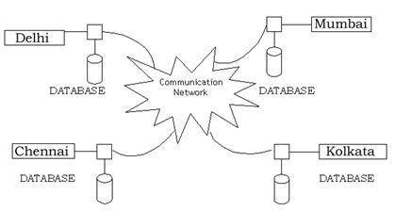](https://krazytech.com/projects/sample-software-requirements-specificationsrs-report-airline-database/attachment/ad-distributed-database-located-at-four-different-cities)

*Distributed database located in four different cities*

**CLIENT/SERVER SYSTEM**

The term client/server refers primarily to an architecture or logical division of responsibilities, the client is the application (also known as the front-end), and the server is the DBMS (also known as the back-end).

A client/server system is a distributed system in which,

* Some sites are client sites and others are server sites.
* All the data resides at the server sites.
* All applications execute at the client sites.

### 4. EXTERNAL INTERFACE REQUIREMENTS

4.1 USER INTERFACES

* Front-end software: Vb.net version
* Back-end software: SQL+

4.2 HARDWARE INTERFACES

* Windows.
* A browser which supports CGI, HTML & JavaScript.

**4.3 SOFTWARE INTERFACES**

Following are the software used for the flight management online application. <<*Include the software details as per your project*>>

|  |  |
| --- | --- |
| **Software used** | **Description** |
| Operating system | We have chosen Windows operating system for its best support and user-friendliness. |
| Database | To save the Patients Data, Information and so on. |
| C# | To implement the project, we have chosen C# language for its more interactive support. |

**4.4 COMMUNICATION INTERFACES**

This project supports all types of web browsers. We are using simple electronic forms for the reservation forms, ticket booking etc.

### NONFUNCTIONAL REQUIREMENTS

**5.1 PERFORMANCE REQUIREMENTS**

The steps involved to perform the implementation of airline database are as listed below.

**A) E-R DIAGRAM**

The E-R Diagram constitutes a technique for representing the logical structure of a database in a pictorial manner. This analysis is then used to organize data as a relation, normalizing relation and finally obtaining a relation database.

* **ENTITIES:**Which specify distinct real-world items in an application.
* **PROPERTIES/ATTRIBUTES:** Which specify properties of an entity and relationships.
* **RELATIONSHIPS:** Which connect entities and represent meaningful dependencies between them.

**B) NORMALIZATION:**

The basic objective of normalization is to reduce redundancy which means that information is to be stored only once. Storing information several times leads to wastage of storage space and increase in the total size of the data stored.

If a database is not properly designed it can give rise to modification anomalies. Modification anomalies arise when data is added to, changed or deleted from a database table. Similarly, in traditional databases as well as improperly designed relational databases, data redundancy can be a problem. These can be eliminated by normalizing a database.

Normalization is the process of breaking down a table into smaller tables. So that each table deals with a single theme. There are three different kinds of modifications of anomalies and formulated the first, second and third normal forms (3NF) is considered sufficient for most practical purposes. It should be considered only after a thorough analysis and complete understanding of its implications.

**5.2 SAFETY REQUIREMENTS**

If there is extensive damage to a wide portion of the database due to catastrophic failure, such as a disk crash, the recovery method restores a past copy of the database that was backed up to archival storage (typically tape) and reconstructs a more current state by reapplying or redoing the operations of committed transactions from the backed up log, up to the time of failure.

**5.3 SECURITY REQUIREMENTS**

Security systems need database storage just like many other applications. However, the special requirements of the security market mean that vendors must choose their database partner carefully.

**5.4 SOFTWARE QUALITY ATTRIBUTES**

* **AVAILABILITY:** The flight should be available on the specified date and specified time as many customers are doing advance reservations.
* **CORRECTNESS:** The flight should reach start from correct start terminal and should reach the correct destination.
* **MAINTAINABILITY:** The administrators and flight in chargers should maintain correct schedules of flights.
* **USABILITY:** The flight schedules should satisfy a maximum number of customers’ needs.

**CHAPTER 05**

# Chapter 05

## Result and Data Analysis

### pqrst Report Analysis

Atrial and ventricular depolarization and repolarization are represented on the ECG as a series of waves: the P wave followed by the QRS complex and the T wave.



The first deflection is the P wave associated with right and left atrial depolarization. Wave of atrial repolarization is invisible because of low amplitude.

Normal P wave is no more than 2.5 mm (two-and-a half1-mm-divisions) tall and less than 120 ms (three 1-mm-divisions) in width in any lead.

In sinus rhythm when the SA node is the pacemaker, the mean direction of atrial depolarization (the P wave axis) points downward and to the left, in the general direction of lead II within a coordinate between 15o and 75o and away from lead aVR. On this count the P wave is always positive in lead II and always negative in lead aVR during sinus rhythm. Conversely, a P wave that is positive in lead II and negative in lead aVR indicates normal P wave axis and sinus rhythm.

### Cost Analysis

Due to COVID-19 all of the equipment’s are over cost and tuff to find all the devices. Though it’s a very sensitive and important project for predefine a patient, specially heart abnormality based patient. In this regard we have tried to bye most convenient accessories and equipment’s from Bangladeshi Market. All of equipment’s cost are mentioned bellow as Table 5.1.

|  |  |  |  |
| --- | --- | --- | --- |
| Serial | Description | Qty | Cost |
|  | Arduino MEGA ATmega2560 | 1pc | 1000 |
|  | ECG AD8232 | 1pc | 350 |
|  | Heartbeat sensor MAX30100 | 1pc | 250 |
|  | ECG Pad | 3pc | 2000 |
|  | Jumper wires | 2 set | 150 |
|  | Breadboard | 1 pc | 80 |
|  | Glue Gun | 1 pc | 350 |
|  | Others | N/A | 500 |
| Total | | | **4680** |

**CHAPTER 06**

# Chapter 06

## Conclusion and Future Scope

### **Conclusion**

The whole systems activities are divided into three major parts like patients, doctors, and admin. Each one has their own role to perform and system respond accordingly. Several agents have been created using web services and inter agent communication is done. Ontologies in form of xml are used for storing information. Different ontologies have been created for different purpose. For implementing the system .Net technologies like ASP.Net, C#, jQuery, Ajax, CSS are used. Current Dialog patient conversation and News part are dynamic and it is a part of Content Management System (CMS). Some parts used CMS concept and works exactly like them. In CMS also xml files are used for managing the states and information. In this system ontology plays similar role. The system comprise of following features.

* Management of Doctors
* Management of Patients
* Management of Schedules of Doctor
* Management of Patients Appointments
* Management of Patient – Doctor Dialogs
* Services supported by hospitals
* Managing Reports
* Feedbacks Management
* Inquiry Management
* Specialty Management
* Searching Information
* Managing useful information in form of News
* Management of Patient‘s previous visit and its information

### **Future Scope**

There are also few features which can be integrated with this system to make it more flexible. Below list shows the future points to be consider.

* Directly getting the images for CT Scan or X-Rays from connected device
* Mapped with Insurance Companies for claim processing
* Billing of patients
* Blood Bank Information Management
* Producing ECG using connected device
* Video Conferencing facility for remote areas for treatments
* Hangout for different doctors and patients at different locations

**CHAPTER 07**

# Chapter 07

## Reference

1. Automatic heartbeat monitoring system <https://www.heighpubs.org/hjcr/acr-aid1018.php>
2. Continuous Heart Rate and Body Temperature Monitoring System using Arduino UNO and Android Device, 28 January 2016
3. Smart Heart Rate Monitoring System, 14 June 2018
4. The future of remote ECG monitoring systems <http://www.jgc301.com/ch/reader/create_pdf.aspx?file_no=20160615001&flag=1>
5. Designing and Implementation of a Heart Failure Telemonitoring System <https://www.ncbi.nlm.nih.gov/pmc/articles/PMC5639891/>
6. In-Home Cardiovascular Monitoring System for Heart Failure: Comparative Study <https://mhealth.jmir.org/2019/1/e12419/>
7. “UML - Standard Diagrams” https://www.tutorialspoint.com/uml/uml_standard_diagrams.htm [Oct. 18, 2017]
8. “Implementation of a medical support system considering P2P and IoT technologies” https://www.computer.org/csdl/proceedings/cisis/2014/4325/00/4325a101-abs.html [Sept 7, 2017]
9. Iman Azimi, Arman Anzanpour, Amir M. Rahmani, Pasi Liljeberg, Tapio Salakoski, “Medical Warning System Based on Internet of Things Using Fog Computing”.
10. <https://www.livescience.com/42081-normal-heart-rate.html>
11. Channappa Bhyri, Kalpana. V, S.T.Hamde, and L.M. Waghmare"Estimation of ECG features using Lab VIEW" TECHNIA -International Journal of Computing Science and Communication Technologies, VOL. 2, NO. I, July 2009. (ISSN 0974-3375)
12. T ouati, R. Tabish, and A. B. Mnaouer, ― A real-time BLE enabledECG system for remote monitoring,‖ APCBEE Procedia, vol. 7, no. 0, pp. 124 – 131, 2013, the 3rd International Conference on Biomedical Engineering and Technology - ICBET 2013
13. D. Benitez, P.A. Gaydecki, A Zaidi, A P. Fitzpatrick, The use of the Hilbert transform in ECG signal analysis, Comput. Biol.Med. 31 (2001) pp. 399-406.
14. He S, Chen J et al. (2014) Mobility and intruder prior information improving the barrier coverage of sparse sensor networks. IEEE Transactions on Mobile Computing 13:1268-1282. doi: 10.1109/tmc.2013.129
15. Al-Fuqaha A, Guizani M, Mohammadi M et al. (2015) Internet of things: a survey on enabling technologies, protocols, and applications. IEEE Communications Surveys & Tutorials 17:2347-2376. doi: 10.1109/comst.2015.2444095
16. S. F. Babiker, L. E. Abdel-Khair, S. M. Elbasheer: “Microcontroller Based Heart Rate Monitor using Fingertip Sensors”, UofKEJ, Vol.1, Issue 2, pp. 47-51 (October 2011).
17. Hassanalieragh, M., Page, A., Soyata, T., Sharma, G., Aktas, M., Mateos, G., ... & Andreescu, S. (2015, June). Health monitoring and management using Internet-of-Things (IoT) sensing with cloud-based processing: Opportunities and challenges. In Services Computing (SCC), 2015 IEEE International Conference on (pp. 285-292). IEEE.
18. Tseng K, Lin B, Liao L et al. (2014) Development of a wearable mobile electrocardiogram monitoring system by using novel dry foam electrodes. IEEE Systems Journal 8:900-906. doi: 10.1109/jsyst.2013.2260620
19. Ayaskanta Mishra, Biswarup Chakraborty,” AD8232 based Smart Healthcare System using Internet of Things (IoT),”International Journal of Engineering Research & Technology (IJERT) ,Vol. 7 Issue 04, April2018 .
20. L. E. Abdel-Khair, S.M.S Elbasheer: “Heart Rate Monitor using Microcontroller Fingertip Sensors”, UofKEJ, Vo2.4, Issue 4, pp. 68-72 (October 2012).
21. Phan T et al. Cloud databases for Internet-of-things data. In: Proc. IEEE 2014 International Conference on Internet of Things (iThings), Taipei, Sep. 2014, pp. 117-124.
22. Al-Fuqaha A, Guizani M, Mohammadi M et al. (2015) Internet of things: a survey on enabling technologies, protocols, and applications. IEEE Communications Surveys & Tutorials 17:2347-2376. doi: 10.1109/comst.2015.2444095.
23. Banerjee, A., and Gupta, S., Analysis of smart mobile applications for healthcare under dynamic context changes. IEEE Trans. Mob. Comput. 14:904–919, 2015. doi:10.1109/tmc.2014.2334606 2334606.
24. Carlos.C "Heart Rate Monitor and Electrocardiograph Fundamentals", Free Scale Semiconductor Application Note, Document Number: AN4059, Rev.O, 3/2010.
25. X. Xu, Y. Liu, ECG QRS complex detection using slope vector wavefonn (SVW) algorithm, in: Proceedings of the 26tl' International Conference of the IEEE EMBS, 2004, pp. 3597-3600.
26. Islam, M. R., Ahmad, S. , Hirose, K., & Molla,M. K. 1. (May 30 2010- June 2 2010). Data adaptive analysis of ECG signals for cardiovascular disease diagnosis. Paper presented at the Circuits and Systems(ISCAS), Proceedings of 2010 IEEE International Symposium.
27. Phan, T., and et al., Cloud databases for Internet-of-things data. In: Proceedings IEEE 2014 International Conference on Internet of Things (iThings), pp. 117–124. Taipei, 2014.
28. Himanshu. S, 1.Sam. 1. K, Y.Ashok and Dr.A.Vimala Juliet, "Advanced ECG signal Processing using Virtual Instrument", International J. of Recent Trends in Engineering and Technology, Vol.3, No.2, May 2010, pp111-114.
29. M. Abo-Zahhad, SabahM. Ahmed, and O. Elnahas -A Wireless Emergency Telemedicine System for Patients Monitoring and Telemedicine and Applications Volume 2014, Article ID 380787, 11 pages
30. Online:“<https://www.researchgate.net/publication/310821467_An_IoTcloud_Based_Wearable_ECG_Monitoring_System_for_Smart_Healthcare>” [25/08/2019 AT 02:06pm]
31. Online:“<https://randomnerdtutorials.com/what-is-mqtt-and-how-it-works/>” [11/09/2019 – AT 02:06]
32. He S, Chen J et al. (2014) Mobility and intruder prior information improving the barrier coverage of sparse sensor networks. IEEE
33. Transactions on Mobile Computing 13:1268-1282. doi: 10.1109/tmc.2013.129
34. He S, Chen J et al. (2014) Mobility and intruder prior information improving the barrier coverage of sparse sensor networks. IEEE
35. Transactions on Mobile Computing 13:1268-1282. doi: 10.1109/tmc.2013.129
36. Al-Fuqaha A, Guizani M, Mohammadi M et al. (2015) Internet of things: a survey on enabling technologies, protocols, and applications.
37. IEEE Communications Surveys & Tutorials 17:2347-2376. doi: 10.1109/comst.2015.2444095
38. Phan T et al. Cloud databases for Internet-of-things data. In: Proc. IEEE 2014 International Conference on Internet of Things (iThings),
39. Taipei, Sep. 2014, pp. 117-124
40. Al-Fuqaha A, Guizani M, Mohammadi M et al. (2015) Internet of things: a survey on enabling technologies, protocols, and applications.
41. IEEE Communications Surveys & Tutorials 17: